**Washington State University  
MIS 420 – Business Intelligence Online**

Mauricio Featherman, Ph.D.

**T-SQL #6**

Name: Nam Jun Lee

Student Number: 11606459

**List of Decision Criteria**

**Decision Criteria 1: Level of Population change & Median Income of the State**

The level of population change and median income of a state are important factors to consider when evaluating migration options. States with a high level of population growth are desirable, as are those with a high median income. The latter is especially important as it can attract skilled workers seeking to advance their careers and enjoy a good standard of living.

**Decision Criteria 2:**

**Level of poverty, High School graduation and Unemployment in the State**

The level of poverty, high school graduation rates, and unemployment in a state are closely interrelated. A lower high school graduation rate often leads to higher unemployment rates and increased poverty levels. It is crucial to consider these factors when evaluating migration options, as high levels of poverty can also lead to higher crime rates.

**Decision Criteria 3: Level of retires & Over 65 in the State**

States with a higher retirement population should provide robust healthcare and ample services for retirees. This is why the proportion of the population aged 65 or older, and the level of retirement in a state, are essential factors to consider when evaluating migration options.

**Decision Criteria 4: GDP growth, and Level of new job in the State**

The growth rate of a state's GDP and the level of new job creation are vital factors to consider when evaluating migration options. Higher GDP growth rates can lead to a higher standard of living and increased innovation, while a strong job market can provide a better chance of employment opportunities for those looking to move.

**Decision Criteria 5: Economic growth in the State**

Small and medium-sized enterprises (SMEs) play a vital role in the US economy. Therefore, the proportion of SMEs in a state is essential to consider when evaluating migration options. Higher proportions of SMEs often correspond to higher GDP growth rates, indicating a prosperous and growing economy.

**Decision Criteria 6: Breweries & Wineries, and Median income of the State**

The presence of breweries and wineries in a state can improve one's quality of life. However, it is also crucial to consider the median income of the state when evaluating migration options, as a low median income could negatively impact one's financial situation despite the presence of breweries and wineries.

**Decision Criteria 7: Racial makeup & Level of new job in the State**

The racial makeup of a state can be an essential factor to consider when evaluating migration options. For instance, individuals of Asian descent may prefer to live in a state with a high proportion of Asians. However, it is also important to consider the job market in a state, as a high racial makeup but low job opportunities could lead to difficulty finding employment.

**Decision Criteria 1:**

**Level of Population change & Median Income of the State**

**Resultant array**

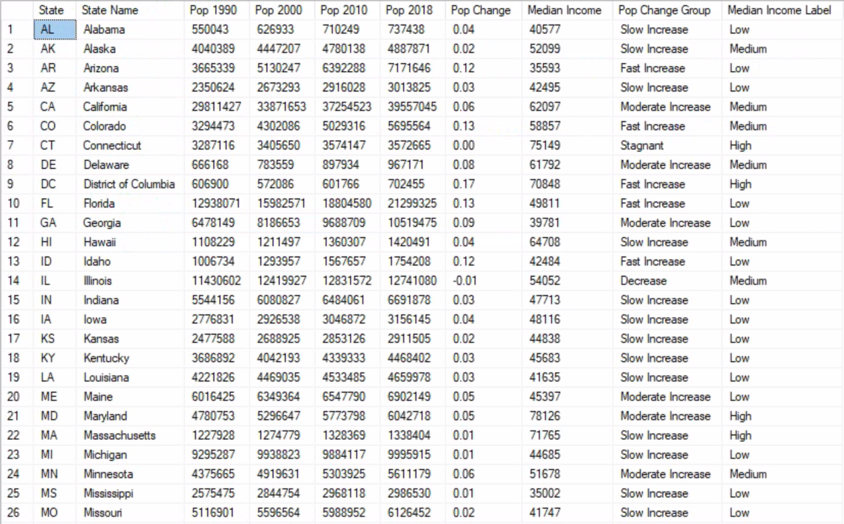

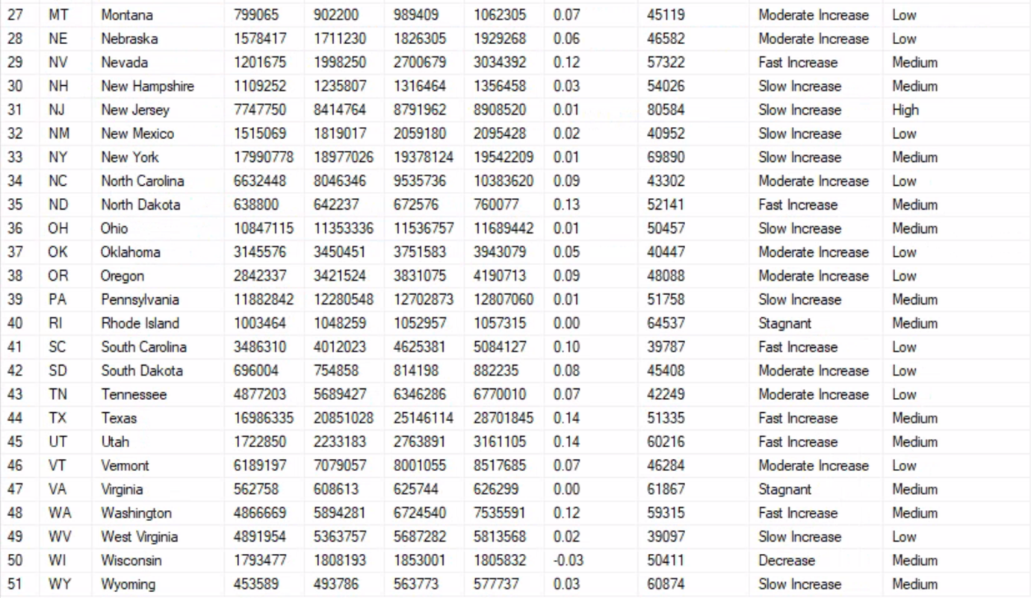

**Part 1**

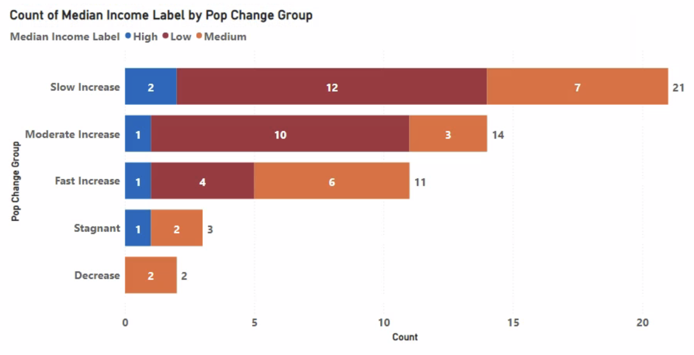

Based on the above graph, I prefer to live in a state with a high population growth rate. However, there are a total of 11 states with high population growth rates, and I prefer to live in a state with an above-median income. Therefore, my options have narrowed down to 7 states through this criterion.

**Part 2**

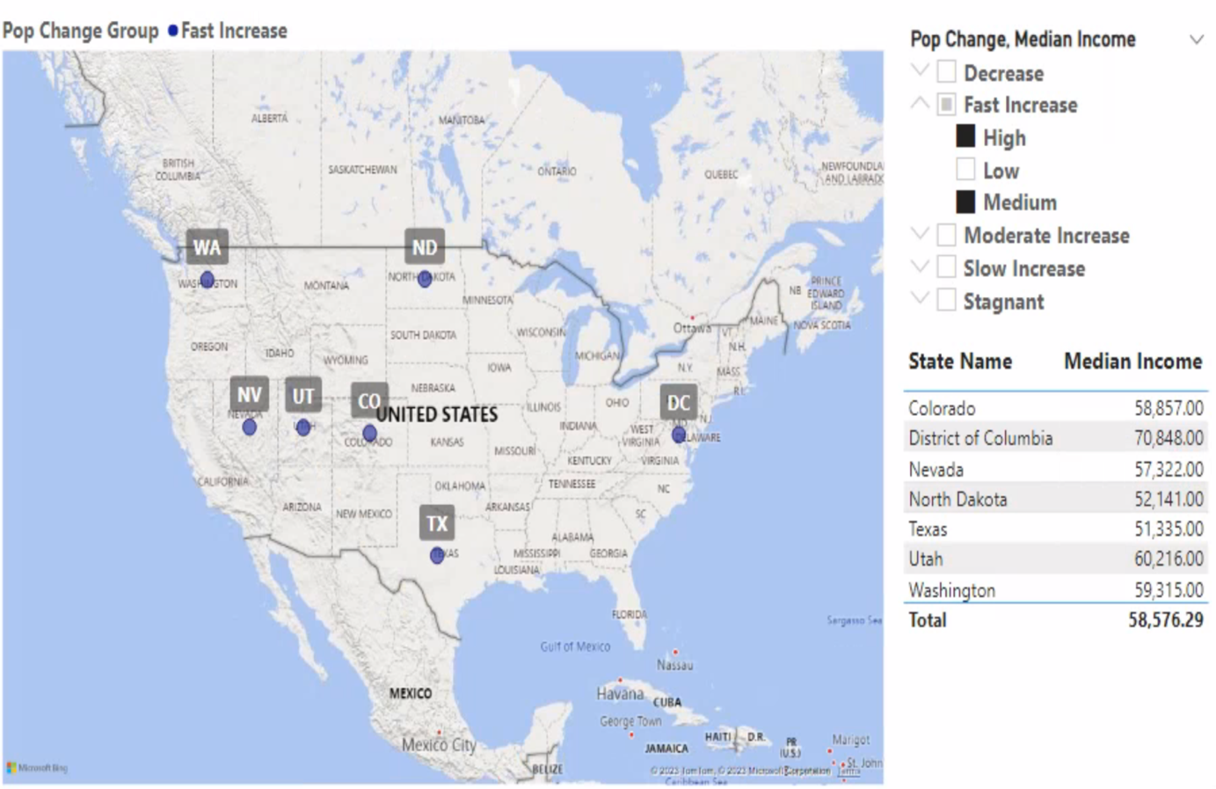

The above graph illustrates the detailed states that fulfill the decision criteria based on population change rate and median income. The criteria have been used to identify seven states that exhibit both a fast increase in population change and either a high or medium median income. Seven states are Colorado, District of Columbia, Nevada, North Dakota, Texas, Utah, and Washington.

Ultimately, based on the Part 1 graph, it is concluded that there is no correlation between population change ratio and median income. This is because groups with rapidly increasing population growth are distributed among groups with lower median incomes, while groups with stagnant or decreasing population growth are distributed among groups with higher or middle median incomes.

Furthermore, through Part 2, the states that meet my selected decision criteria are ultimately **Colorado**, **District of Columbia**, **Nevada**, **North Dakota**, and **Texas**. The median average income of these five states is $58,576.29, fulfilling my decision criteria of rapid population growth and high median income.

**Decision Criteria 2:**

**Level of poverty, High School graduation and Unemployment in the State**

**Resultant array**

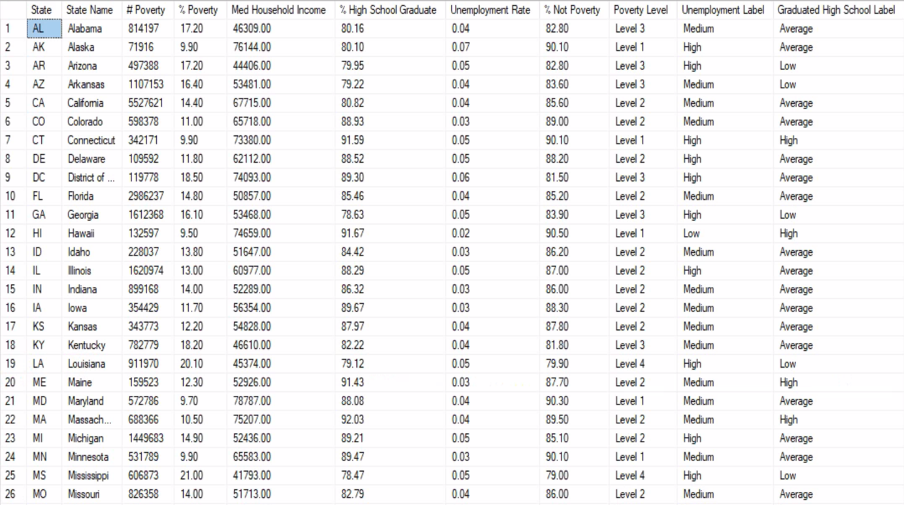

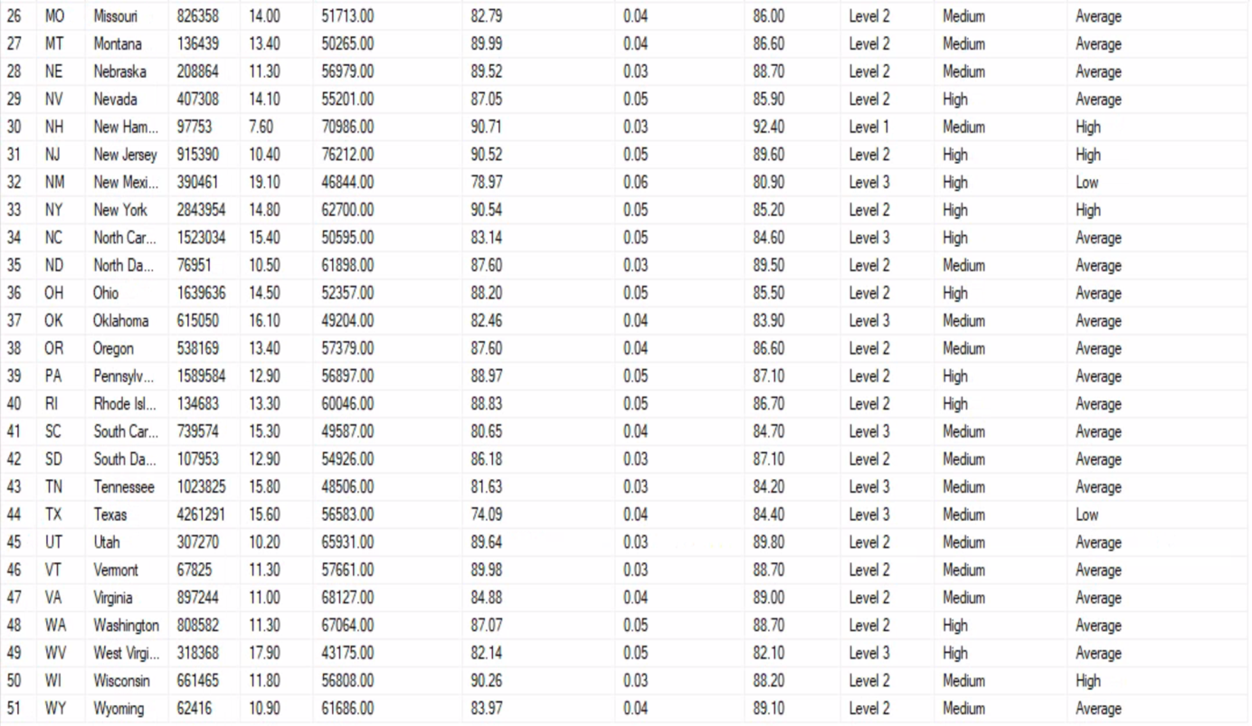

**Part 1**

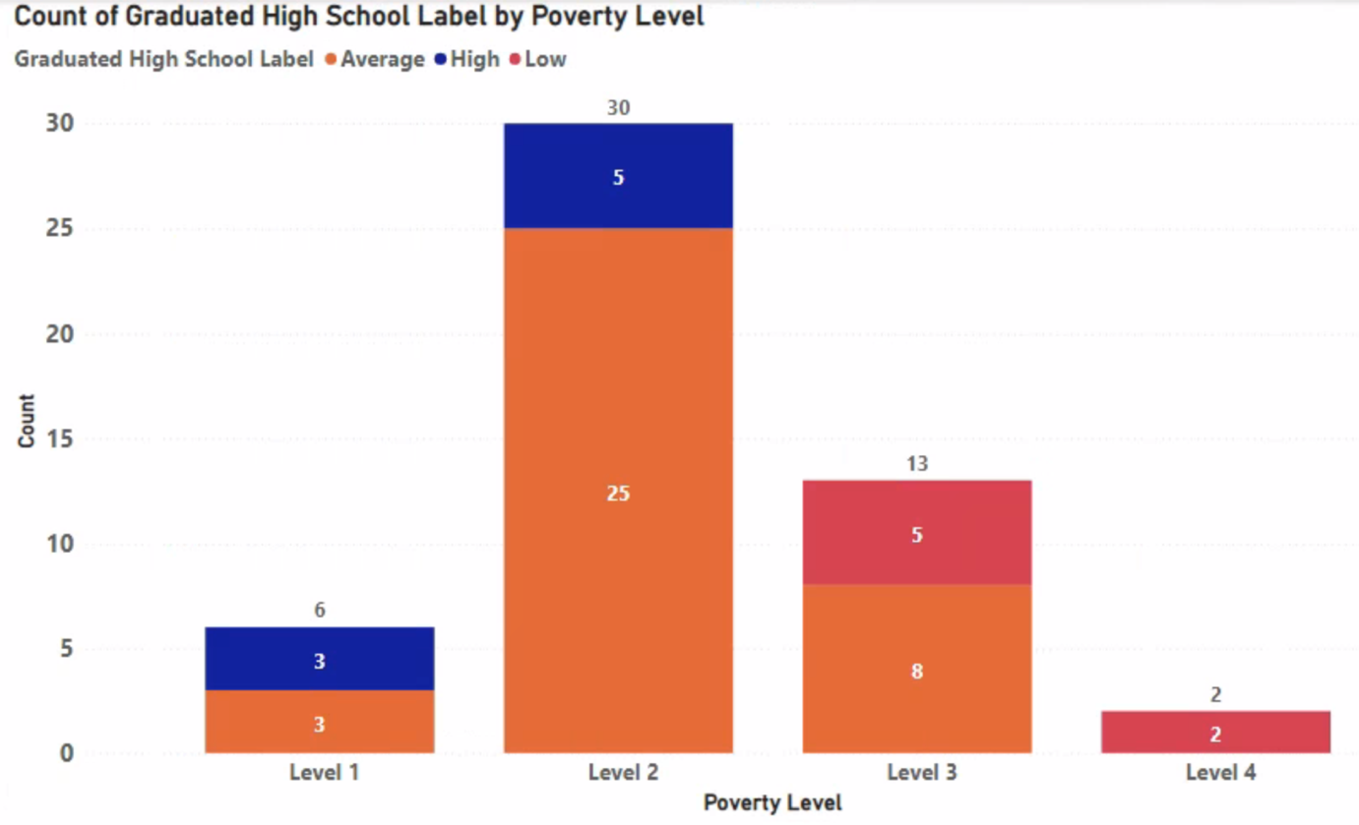

Based on the above graph, I prefer to live in a state with a low poverty rate. However, there are only 6 states with a low poverty rate, and I am specifically interested in those with a high school graduation rate above the median. As a result, my options have been narrowed down to 6 states through this criterion.

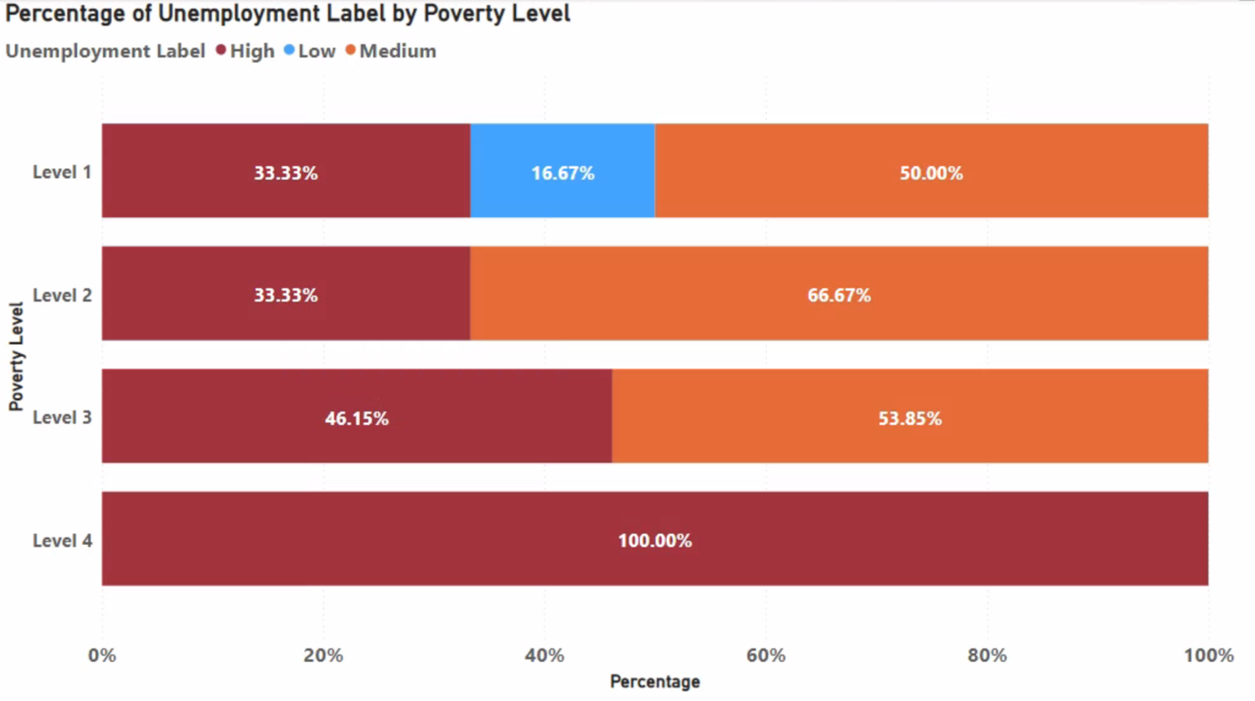

Based on the above graph, it can see that the group of states with a low poverty rate has the lowest unemployment rate among all the groups. This satisfies my decision criteria.

**Part 2**

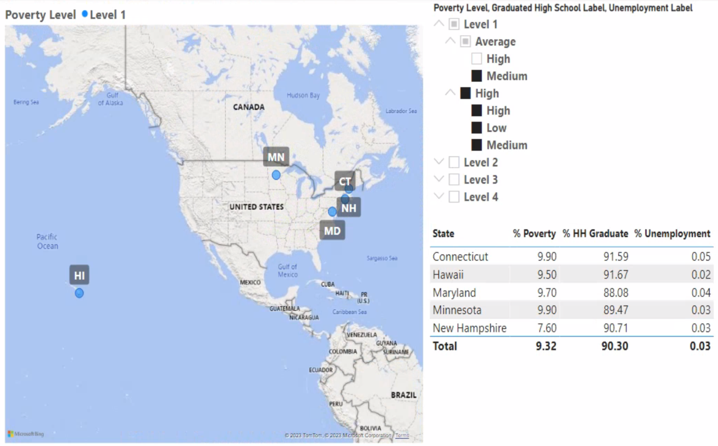

The above graph shows the specific states that meet my decision-making criteria based on poverty rate, high school graduation rate, and unemployment rate. These criteria include states with low poverty rates, high school graduation rates at or above the median, and unemployment rates below 5%. The graph shows five states that meet these criteria, which are Connecticut, Hawaii, Maryland, Minnesota, and New Hampshire.

"Ultimately, based on the Part 1 graph, it can show that there is a correlation between poverty rates and high school graduation rates. The group with lower poverty rates is distributed among groups with higher or at least average high school graduation rates, while the group with higher poverty rates is distributed among groups with lower high school graduation rates. Additionally, it can show that there is also a correlation between poverty rates and unemployment rates. This is because in groups with extremely high poverty rates, only groups with very high unemployment rates are distributed."

Furthermore, through Part 2, the states that meet my final decision-making criteria are **Connecticut**, **Hawaii**, **Maryland**, **Minnesota**, and **New Hampshire**. The average poverty rate of these five states is 9.32, and the average graduation rate is 90.30, which is high, while the average unemployment rate is 0.03, which is low, indicating that they meet my decision-making criteria.

**Decision Criteria 3: Level of retires & Over 65 in the State**

**Resultant array**

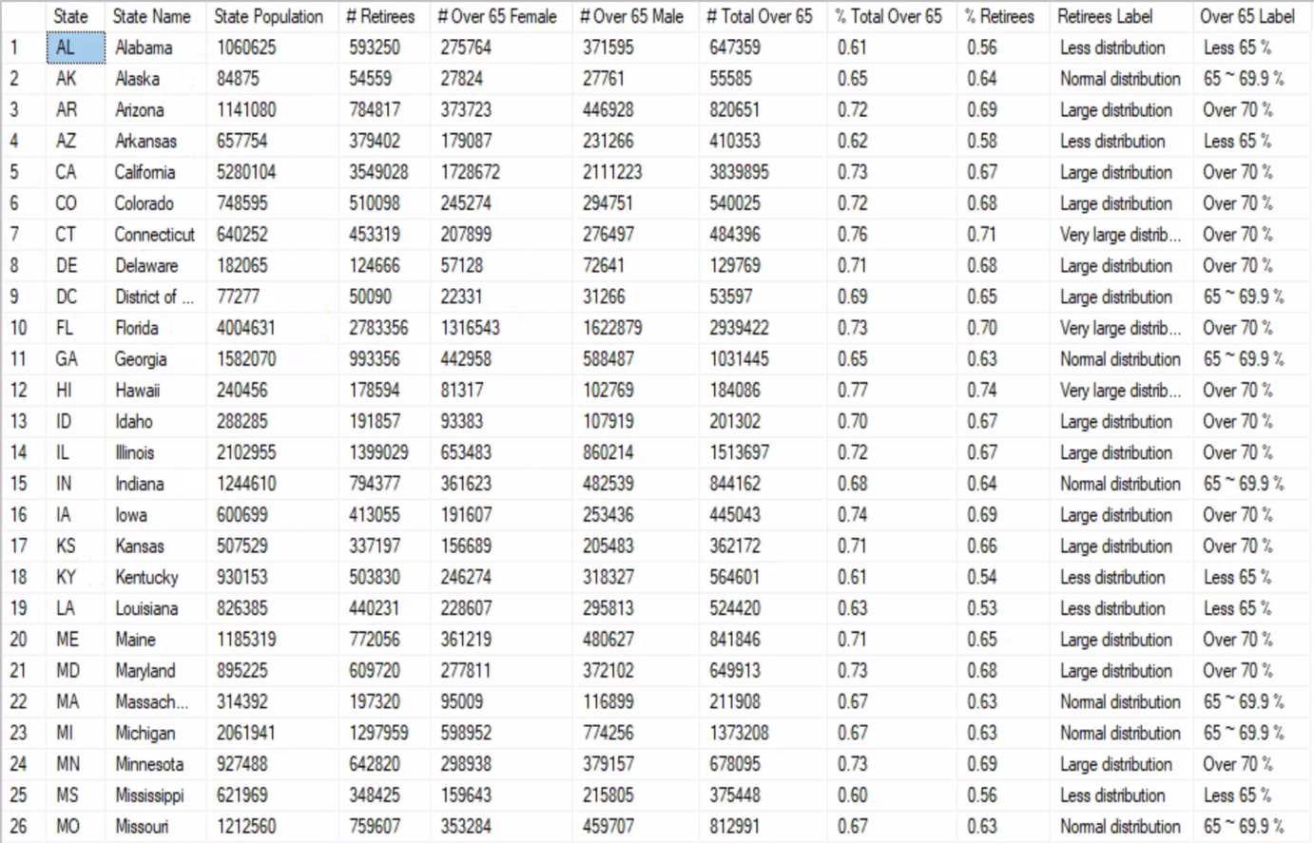

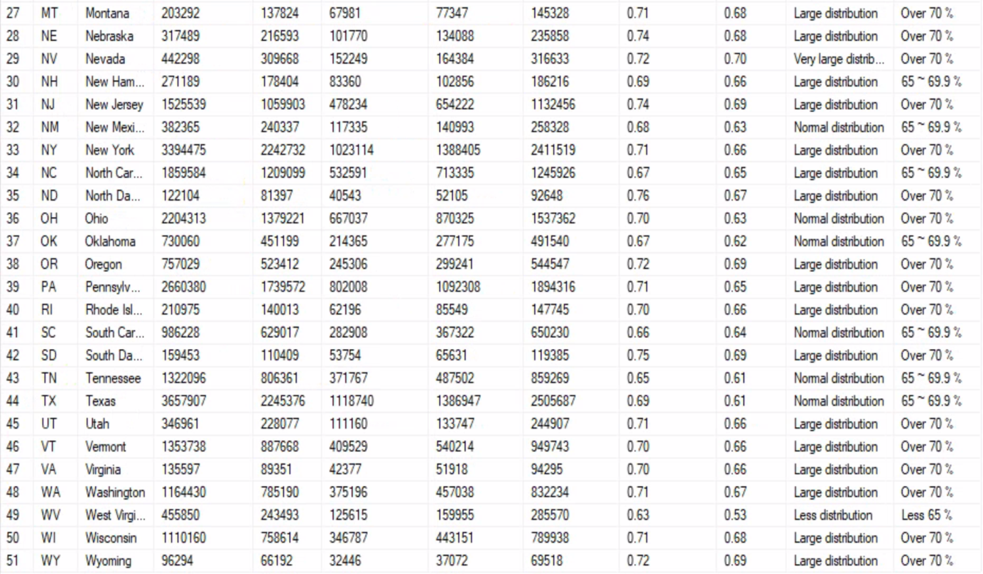

**Part 1**

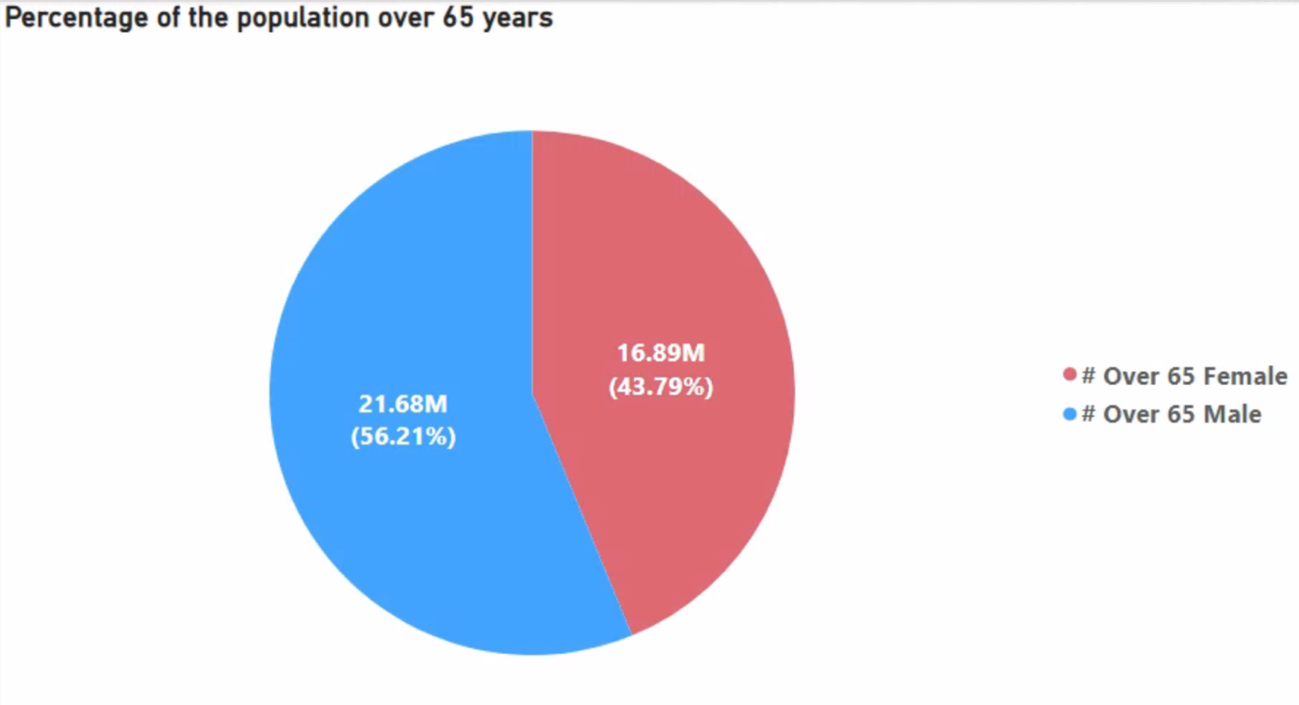

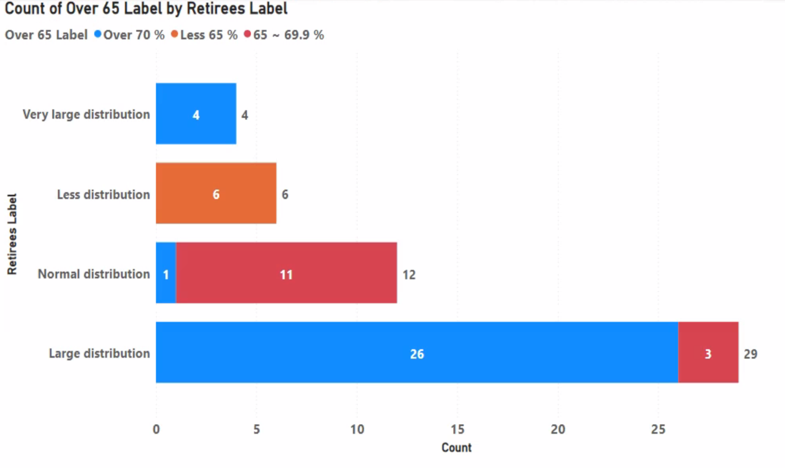

Based on the graphs above, we can see that the percentage of males aged 65 and over is 56.21%, while females make up 43.79%, indicating that there are more males than females in this age group. Additionally, I want to live in a state with a high retirement rate, and there are a total of 33 states with high retirement rates. However, since I specifically want to live in a state where the population aged 65 and over is high, my options are narrowed down to 30 states.

**Part 2**

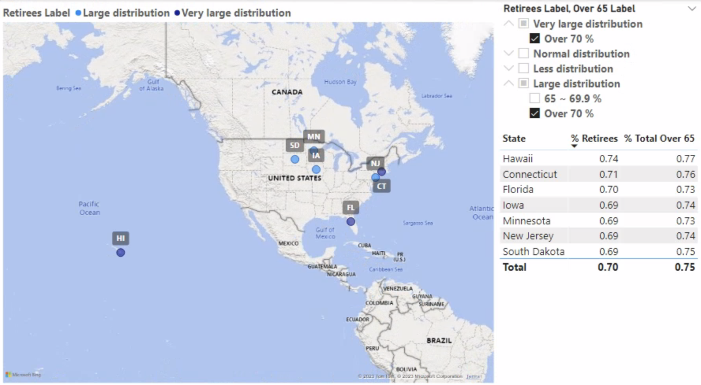

The above graph shows the detailed states that meet the decision criteria based on retirement rate and the distribution rate of people aged 65 and over. The criteria show 7 states with a high retirement rate (more or equal then 0.69) and a distribution rate of 65 and over of 70% (more or equal then 0.73). These 7 states are Hawaii, Connecticut, Florida, Lowa, Minnesota, New Jersey, and South Dakota.

Ultimately, based on Part 1 graph, It can show that there is a correlation between retirement rate and the distribution rate of people aged 65 and over. This is because the group with a high retirement rate is distributed to a group with a high distribution rate of people aged 65 and over, and the group with a low retirement rate is distributed to a group with a low distribution rate of people aged 65 and over.

Furthermore, based on Part 2, the five states that meet my decision criteria are **Hawaii**, **Connecticut**, **Florida**, **Lowa**, and **Minnesota**. The average retirement rate for these five states is 0.70, which is high, and the average distribution rate of people aged 65 and over is 0.75, which is also high, satisfying my decision criteria.

**Decision Criteria 4: GDP growth, and Level of new job in the State**

**Resultant array**

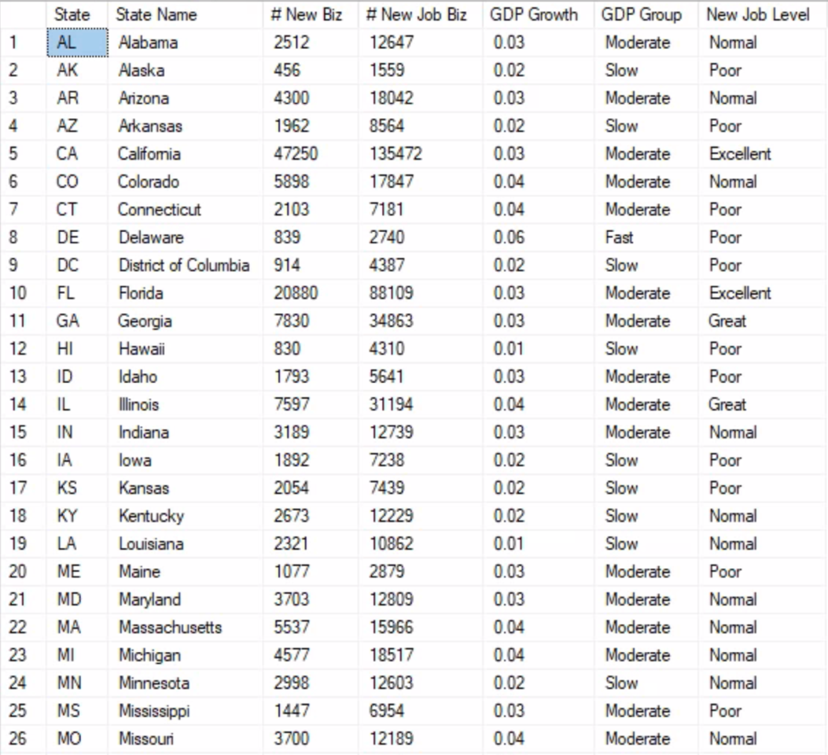

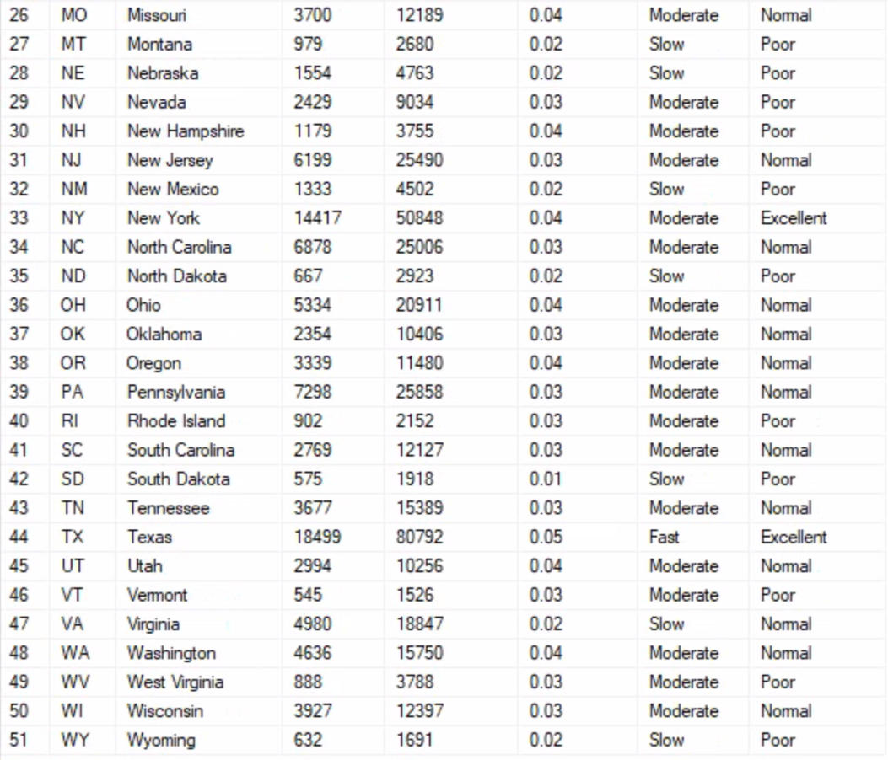

**Part 1**

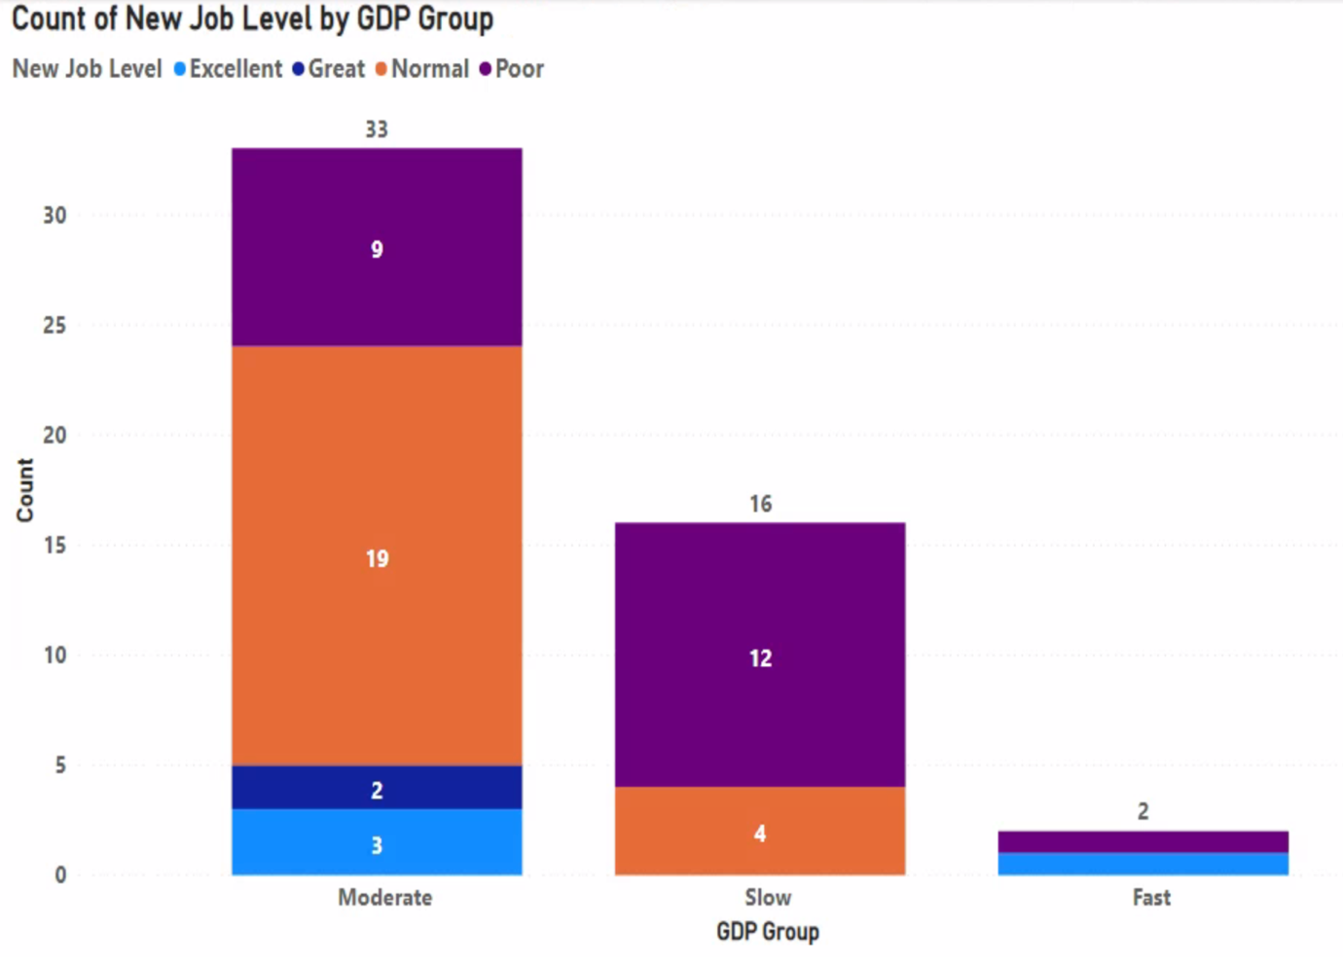

Based on the above graph, I want to live in a state where the GDP growth rate is above average. There are a total of 35 states with a GDP growth rate above average, and I want to live in a state with plenty of new job opportunities (Excellent or Great). As a result, my options are narrowed down to 6 states.

**Part 2**

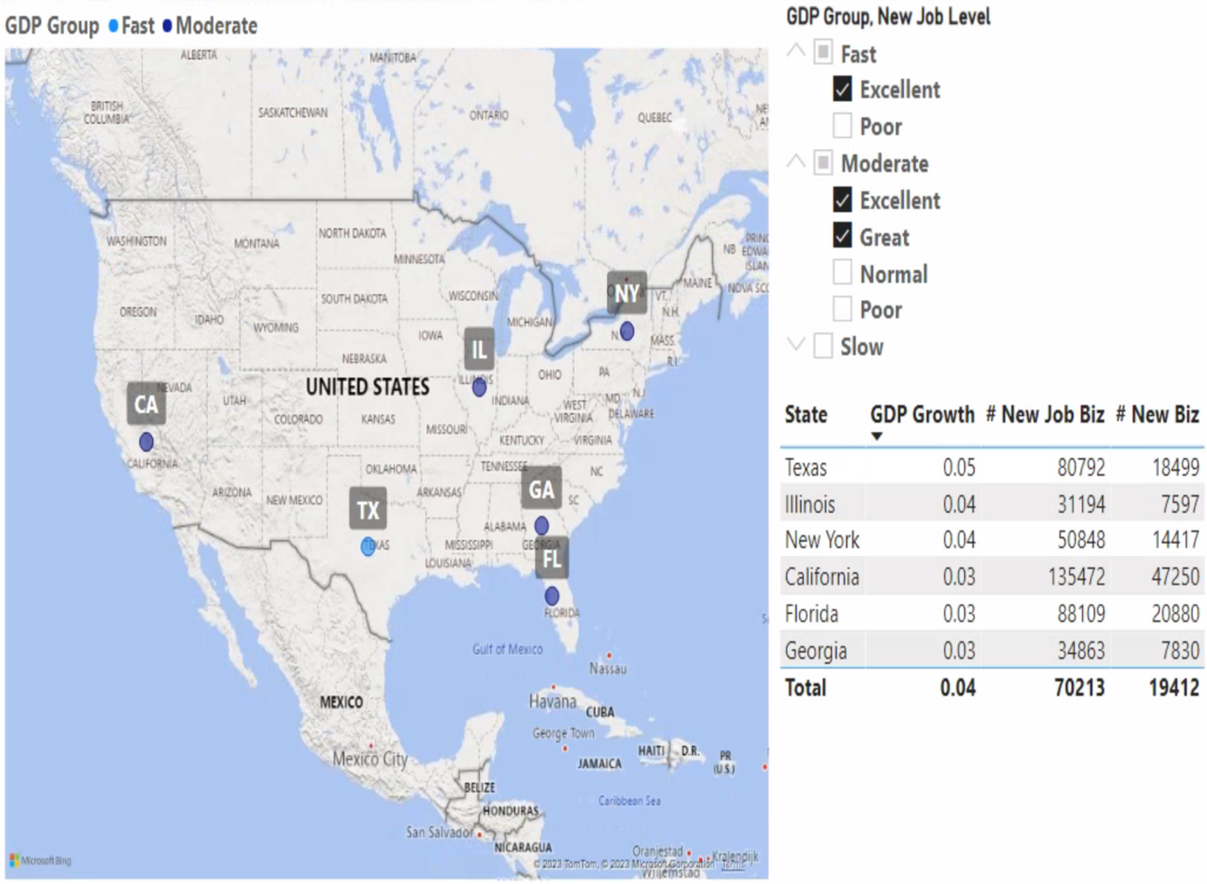

The above graph shows detailed states that meet the decision criteria based on GDP growth rate and new job creation. The criteria indicate states with above-average GDP growth rate and a high number of new jobs, totaling 6 states: Texas, Illinois, New York, California, Florida, and Georgia.

Ultimately, based on the graph in Part 1, It can show that there is no correlation between GDP growth rate and new job creation. This is because the groups of GDP growth rate and new job creation are evenly distributed.

Furthermore, through Part 2, the states that meet my decision criteria are **Texas**, **Illinois**, **New York**, **California**, and **Florida**. The average GDP growth rate for these five states is 0.04, which is high, and the average number of new jobs is 70,213, indicating that they meet my decision criteria.

**Decision Criteria 5: Economic growth in the State**

**Resultant array**

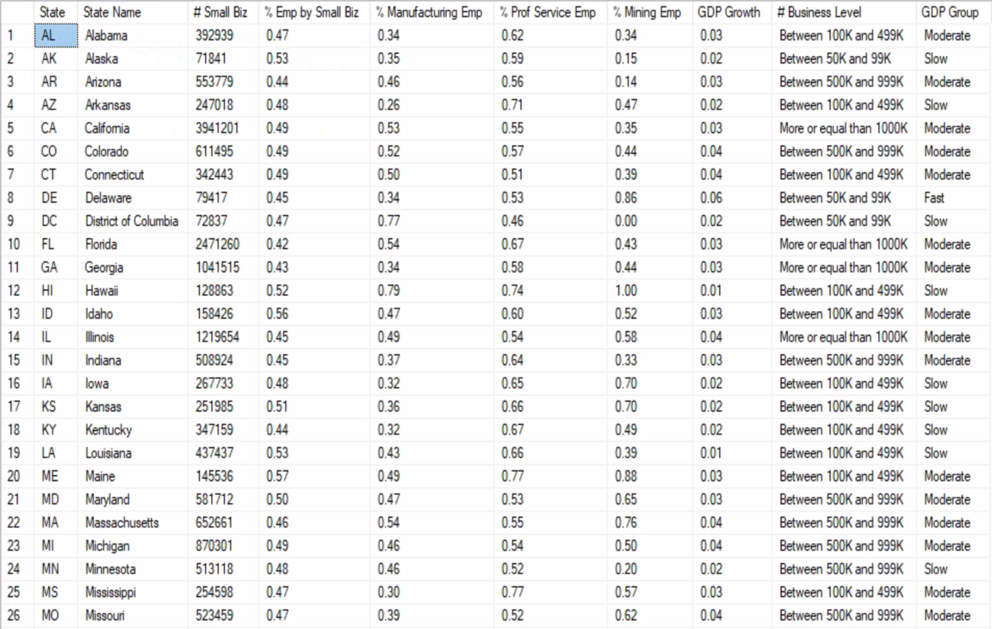

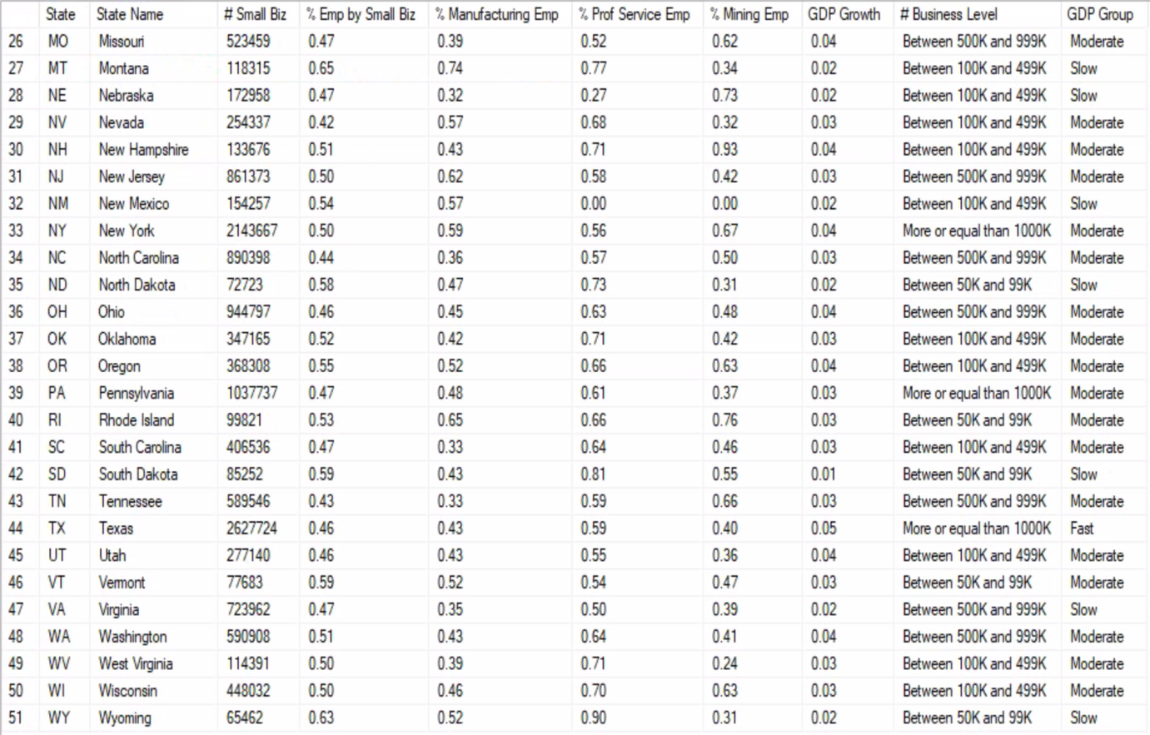

**Part 1**

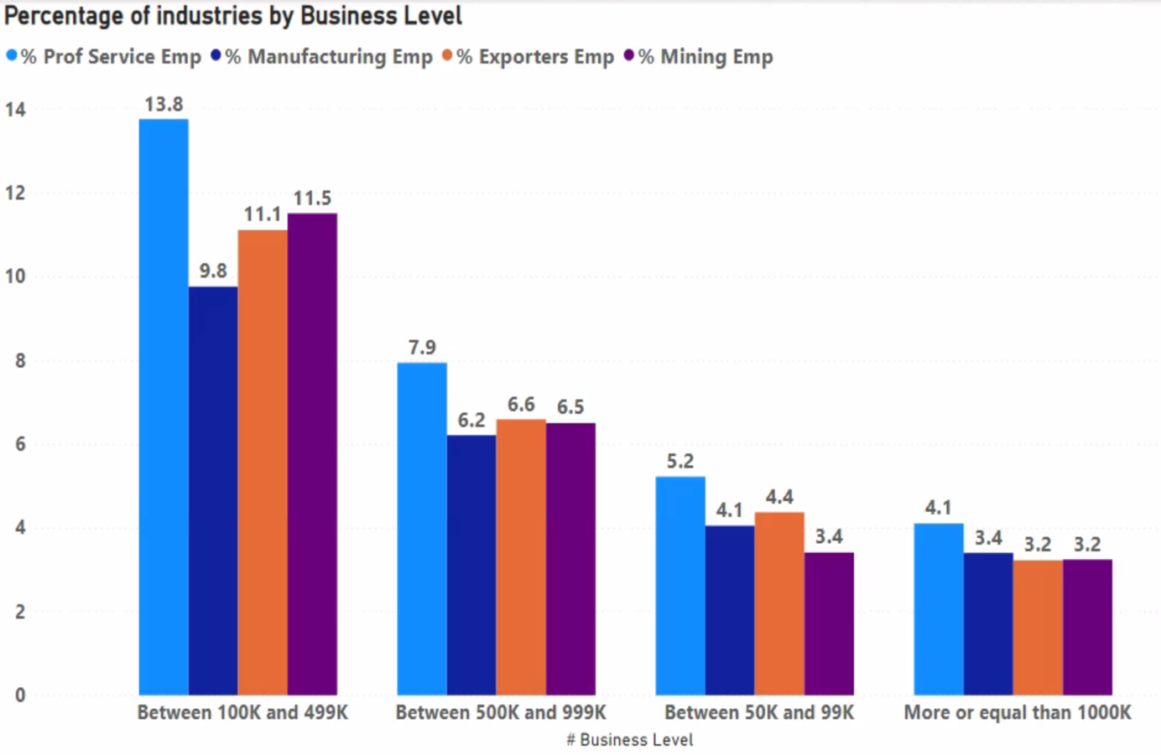

Based on the above graph, I want to live in a state with a high number of small businesses. However, the group with small businesses of 1,000,000 or more has the lowest distribution than the other groups, so my options are narrowed down.

**Part 2**

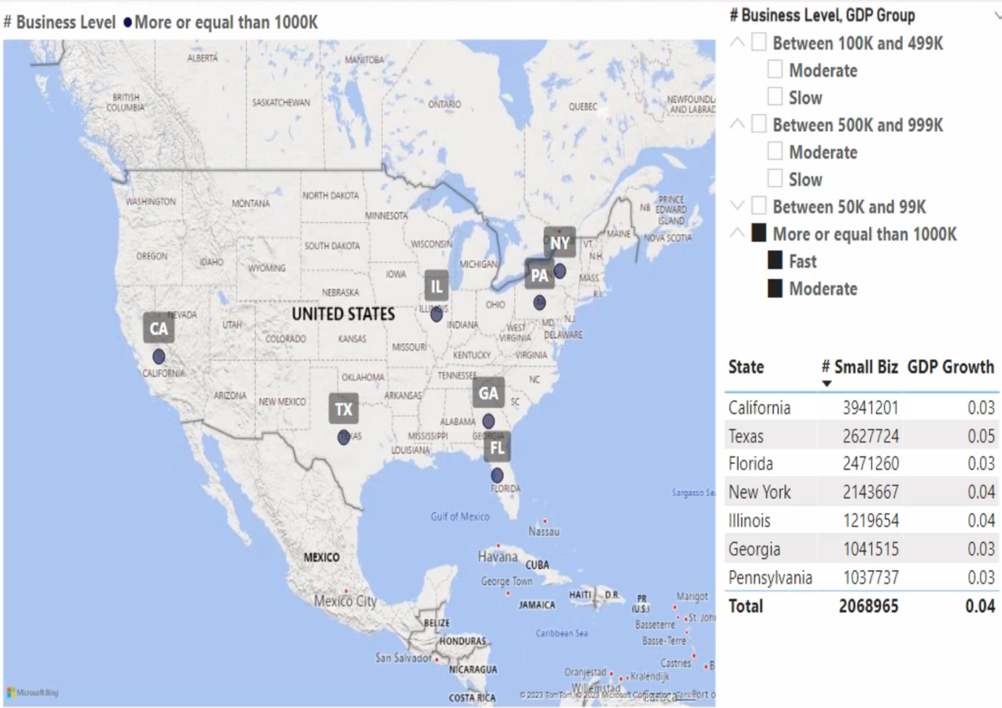

The above graph shows the detailed states that meet the decision-making criteria based on the number of businesses and GDP growth rate. This criterion shows 7 states with over 1,000,000 businesses and above-average GDP growth rates. The 7 states are California, Texas, Florida, New York, Illinois, Georgia, and Pennsylvania.

Ultimately, based on the graph in Part 1, it can show that the group with 1,000,000 or more businesses has the lowest distribution. Additionally, it can show that the distribution of professional service employees is highest in the small business industry on average.

Furthermore, based on Part 2, the states that meet my decision-making criteria are **California**, **Texas**, **Florida**, **New York**, and **Illinois**. These five states have an average of 2,068,965 businesses, which is very high, and an above-average GDP growth rate of 0.04, satisfying my decision criteria.

**Decision Criteria 6: Breweries & Wineries, and Median income of the State**

**Resultant array**

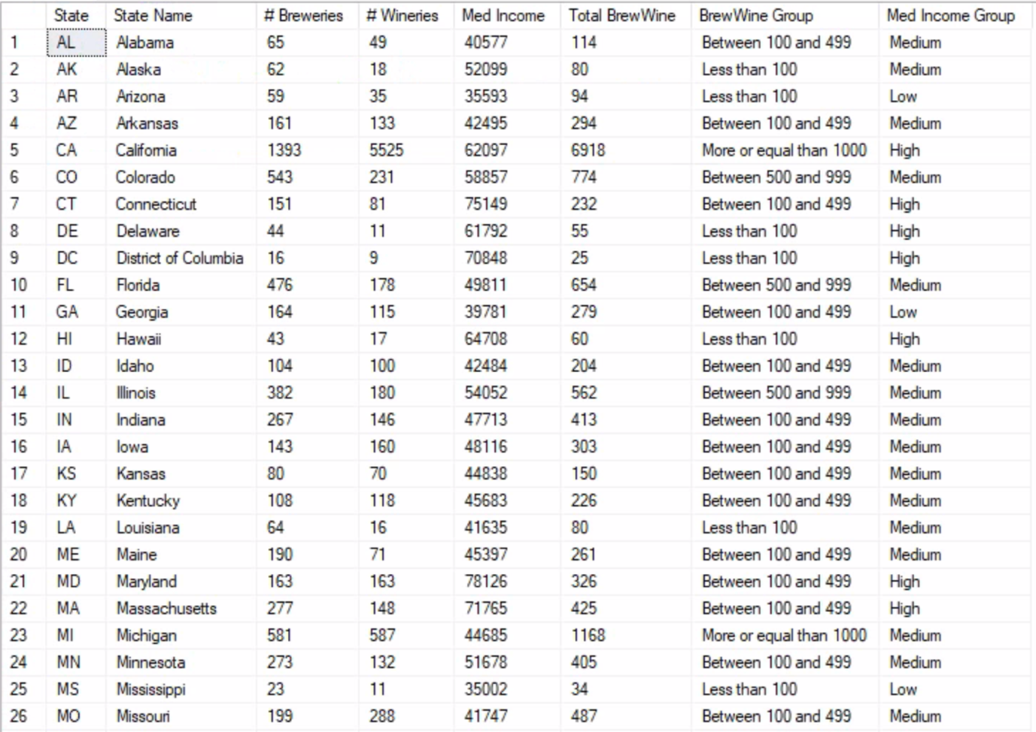

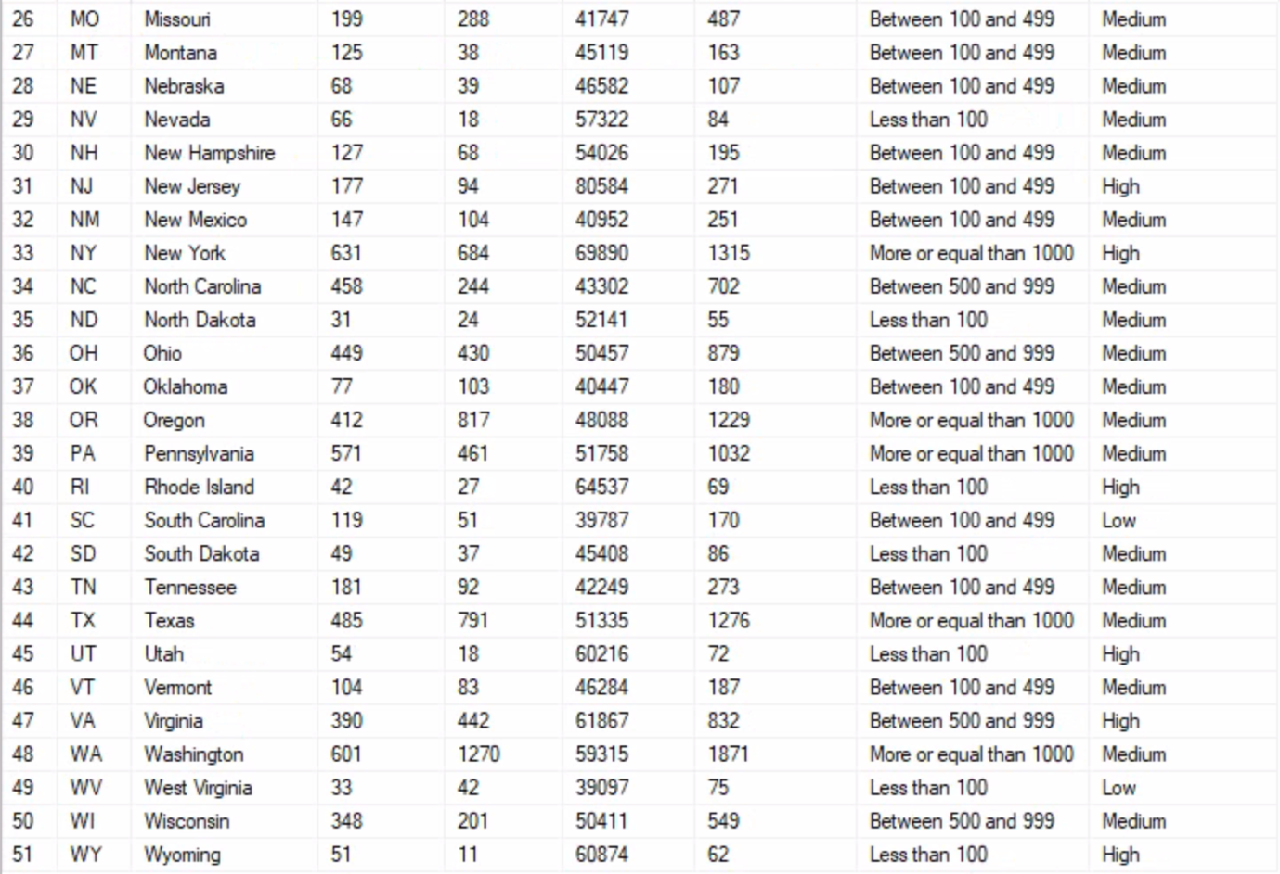

**Part 1**

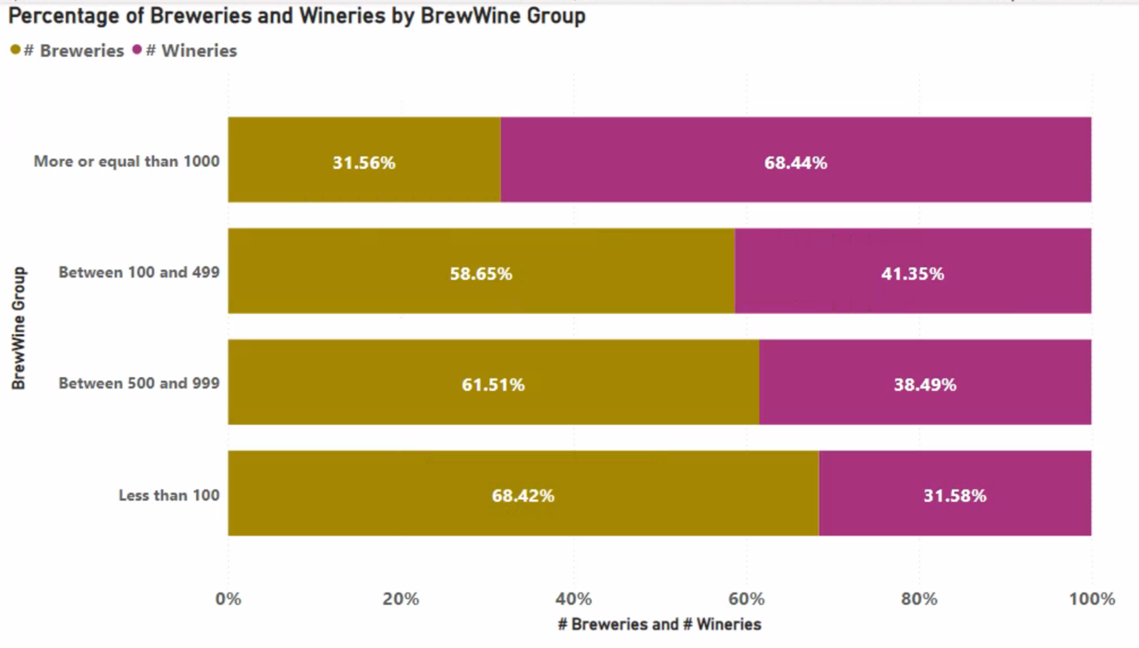

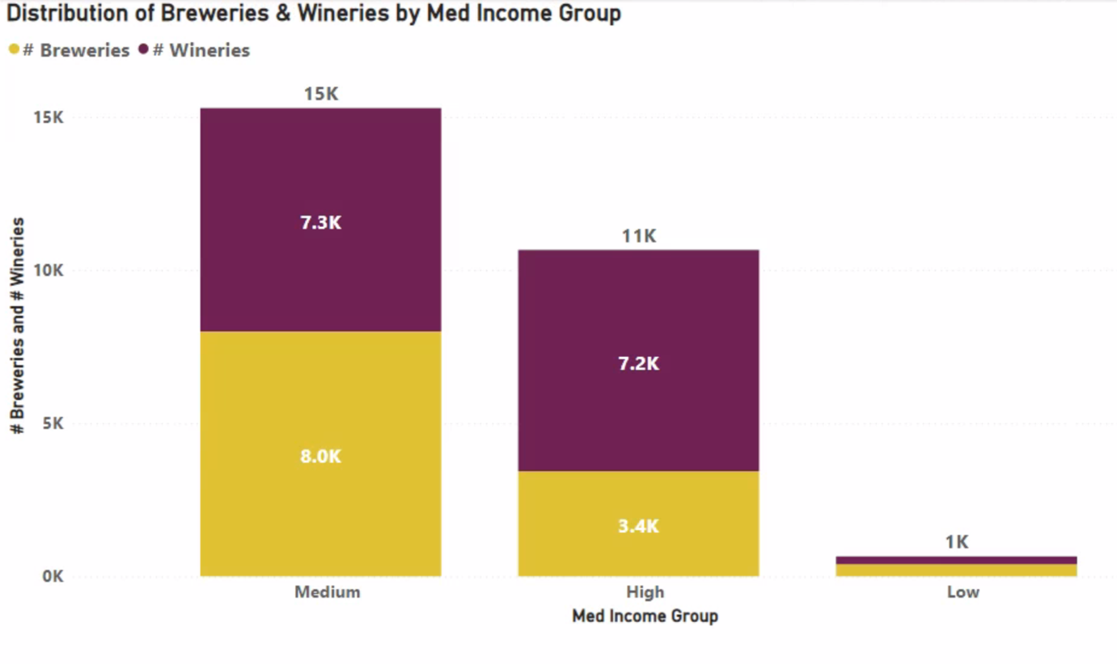

Through the above graphs, it can show that the proportion of wineries in the group with 1000 or more breweries is higher than that of breweries, and the proportion of wineries in the group with fewer breweries and wineries is lower than that of breweries. Moreover, I want to live in a state with many breweries and wineries and a median income above the national average. However, the group with low median income has very few breweries and wineries, which narrows down my options.

**Part 2**

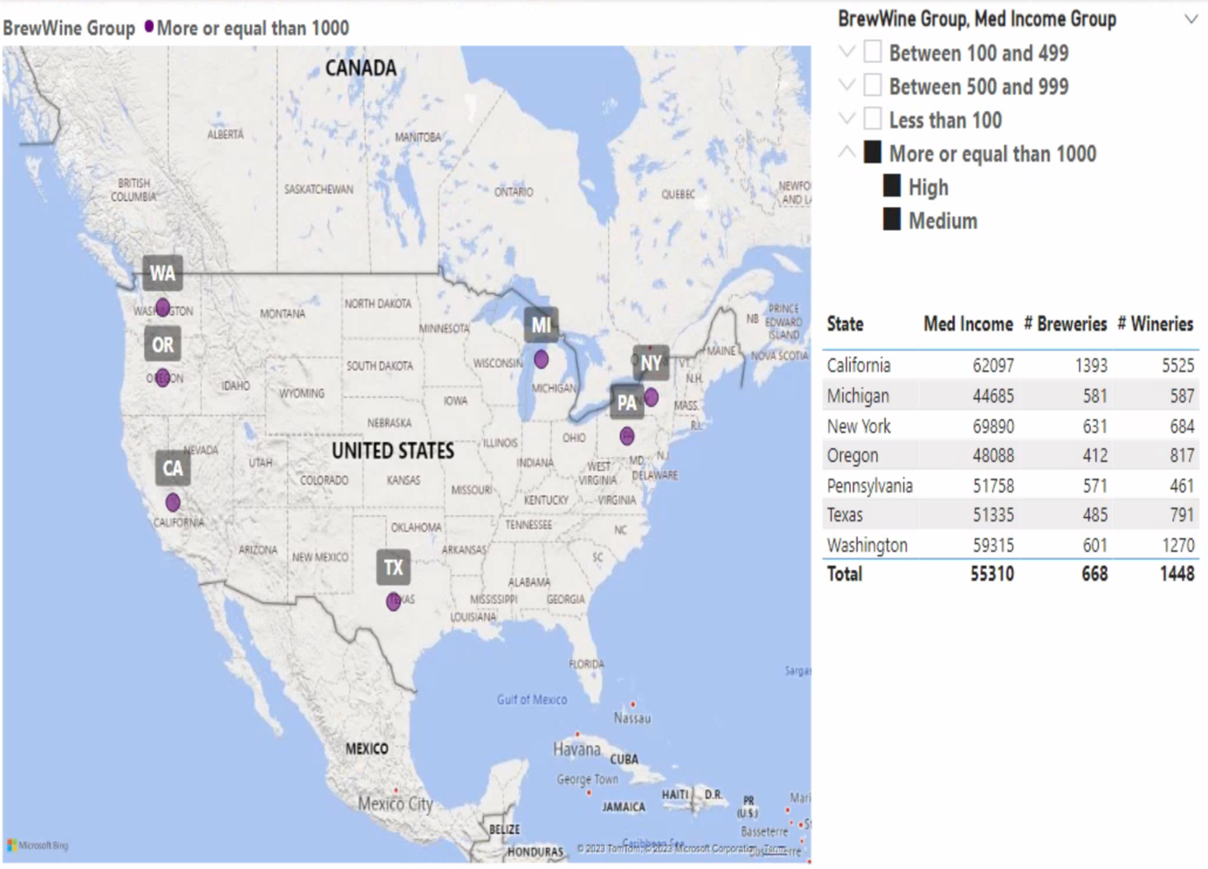

The graph above shows the distribution of breweries and wineries, as well as the median income groups used as decision criteria for identifying specific states that meet the criteria. These criteria include states where breweries and wineries are distributed in more than 1,000 locations and the median income is above average, and seven states meet these criteria: California, Michigan, New York, Oregon, Pennsylvania, Texas, and Washington.

Ultimately, based on the Part 1, it can show that a correlation between the overall distribution of breweries and wineries and the proportion of wineries to breweries. Specifically, as the overall distribution of breweries and wineries increases, wineries are more likely to be more prevalent than breweries, and as the overall distribution decreases, breweries are more likely to be more prevalent than wineries. Additionally, there is a correlation between median income groups and the distribution of breweries and wineries. Specifically, breweries and wineries are more likely to be found in median income groups above the middle range, while they are less likely to be found in groups with lower median incomes.

Furthermore, based on Part 2, the final decision criteria for choosing states that meet the criteria are **California**, **Michigan**, **New York**, **Oregon**, and **Pennsylvania**. The median income of these five states is not low, with an average of $55,310, and the number of breweries and wineries is distributed well, with an average of 668 breweries and 1,448 wineries, satisfying my decision criteria.

**Decision Criteria 7: Racial makeup & Level of new job in the State**

**Resultant array**

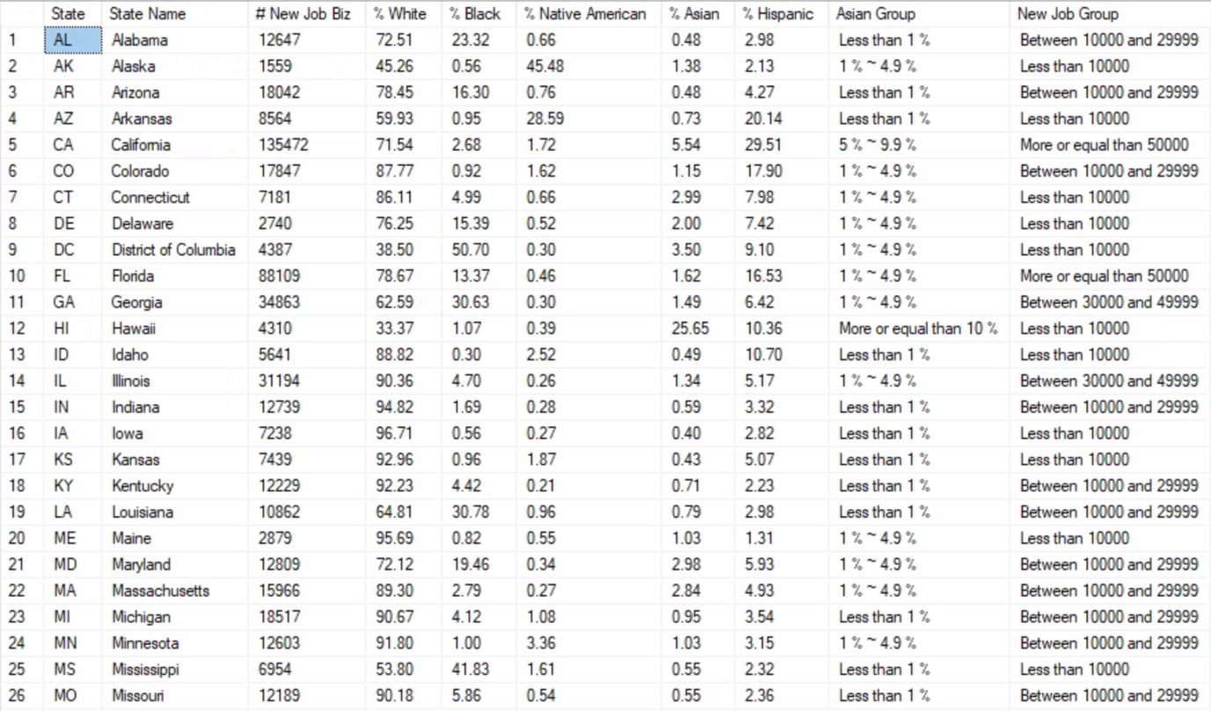

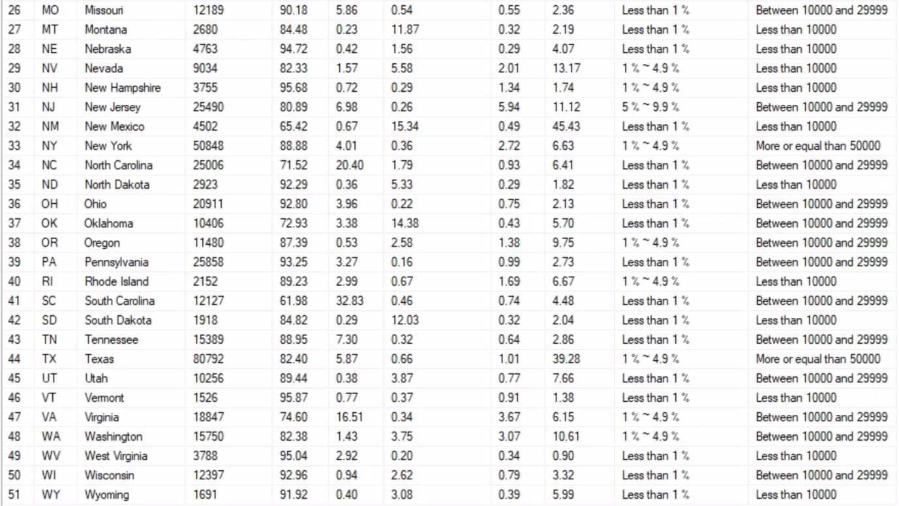

**Part 1**

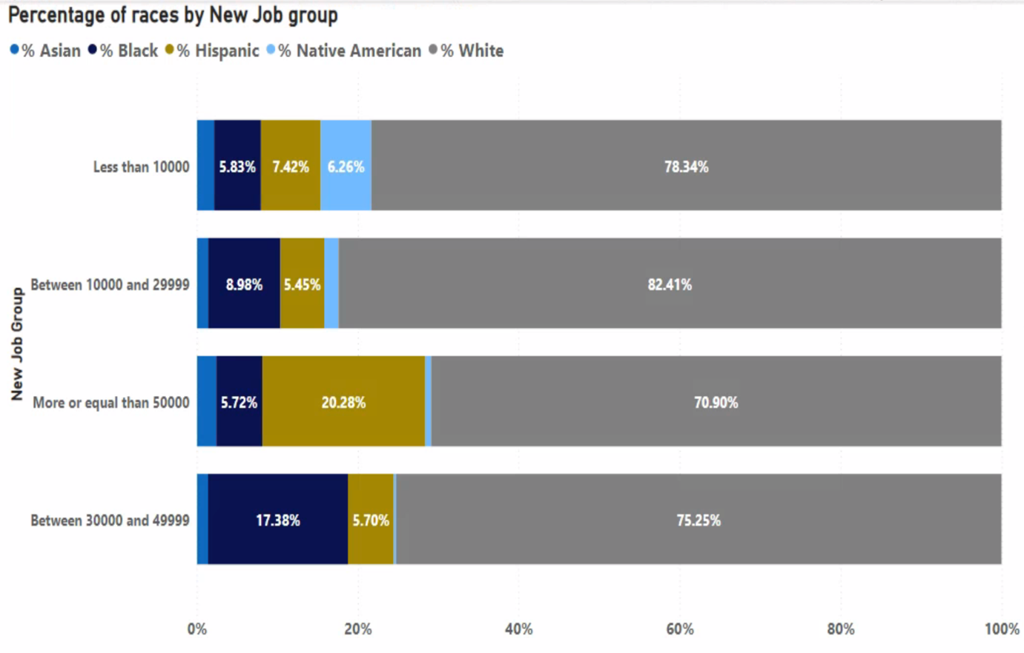

Based on the graphs above, I want to live in a state with a high proportion of Asians and abundant new job opportunities. However, since I noticed that in all the new job distribution groups, there are a lot of White people and very few Asians, it was difficult for me to understand the exact numbers and narrow down my choices.

**Part 2**

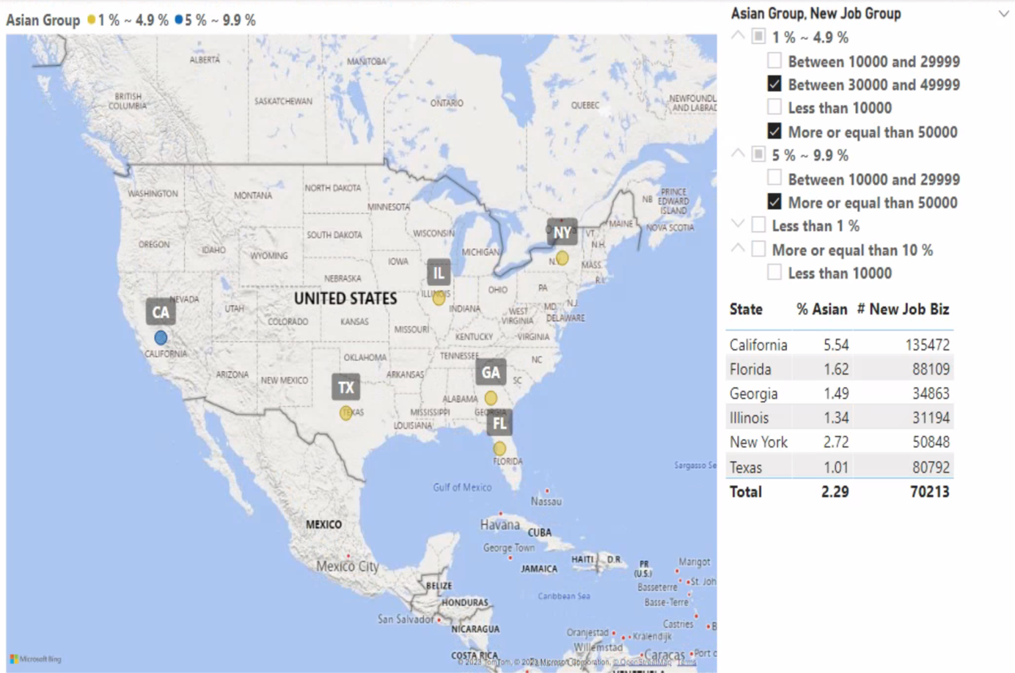

So, based on the above graph, it shows the detailed states that meet the decision criteria based on the percentage of Asians and the new job group. The criteria show six states with over 1% Asian population and more than 30,000 jobs, which are California, Florida, Georgia, Illinois, New York, and Texas.

Ultimately, based on the Part1, it can show that there is no correlation between job distribution groups and race, as White people make up over 70% in all job distribution groups, followed by a significant distribution of Black and Hispanic people. On the other hand, Native Americans and Asians are generally less distributed.

Furthermore, through Part 2, the final decision criteria I selected were met by the states of **California**, **Florida**, **Georgia**, **Illinois**, and **New York**. The average Asian distribution rate for these five states is 2.29%, and the median income is $70,213. Although the Asian distribution rate is lower than what I had expected, the high median income meets my decision criteria.

**Summary**

In summary, among the seven decision criteria that I set, Texas, Florida, New York, California, and Illinois were mentioned the most. Therefore, if I use these decision criteria, I plan to live in **Texas**, **Florida**, **New York**, **California**, and **Illinois**.

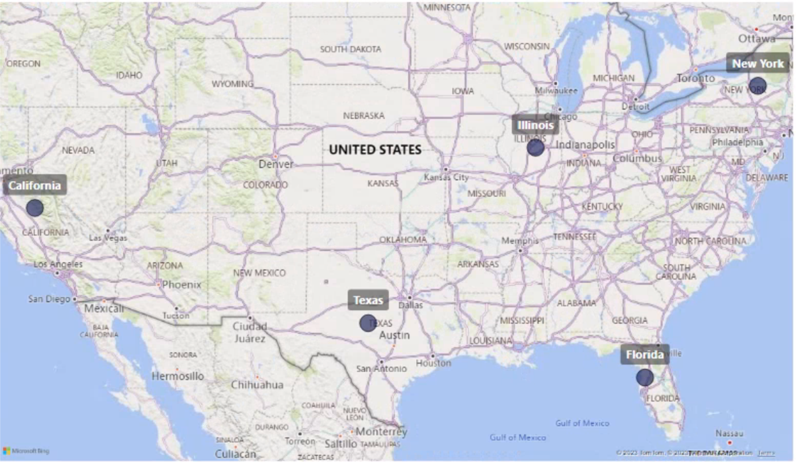

**Extra Credit**

**Airbnb Cleaned Europe Dataset**

**From:** [**https://www.kaggle.com/datasets/dipeshkhemani/airbnb-cleaned-europe-dataset**](https://www.kaggle.com/datasets/dipeshkhemani/airbnb-cleaned-europe-dataset)

**Original Data**

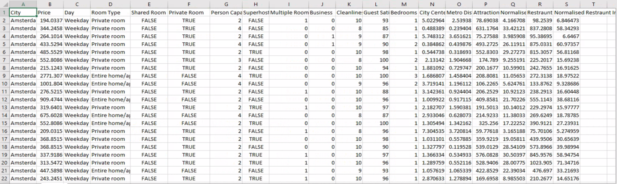

This table contained 19 columns and 41,714 rows.

**Cleaned Data**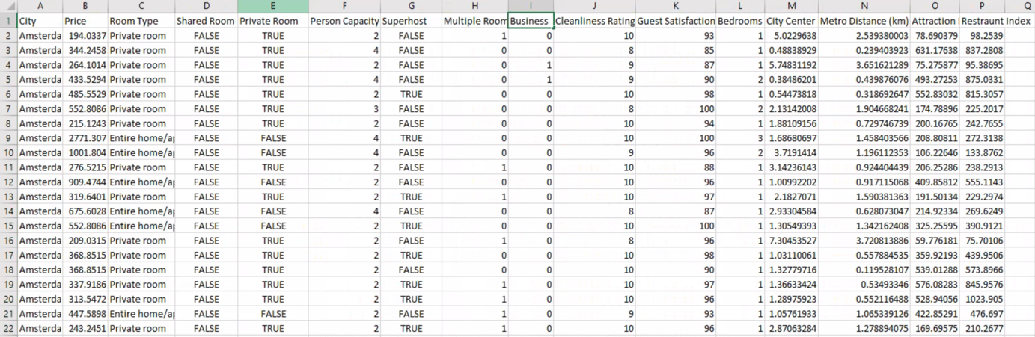

After removing unnecessary columns, this table contains 16 columns and 41,714 rows.

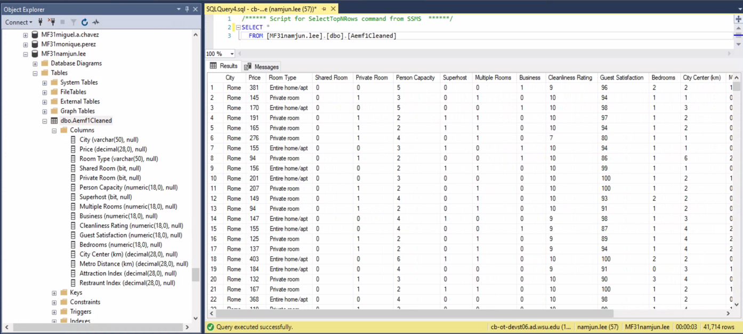

The data was uploaded to the my server space normally, the attributes of all variables were converted while importing data.

**Appendix**

USE [Featherman_Analytics];

-- Create main array

DECLARE @MainTable TABLE ([State] NVARCHAR(2), [State Name] NVARCHAR(50), [# Small Biz] DECIMAL

, [% Emp by Small Biz] DECIMAL(20,2), [Med Income Emp Incorporated] DECIMAL (20,2), [Med Income Emp UNIcorporated] DECIMAL(20,2)

, [# New Biz] DECIMAL, [# New Job for Biz] DECIMAL, [% Exporters Small Biz] DECIMAL (20,2)

, [GDP Growth] DECIMAL(20,2), [Unemployment Rate] DECIMAL(20,2), [% Manufacturing Emp Small Biz] DECIMAL(20,2)

, [% Prof Service Emp Small Biz] DECIMAL(20,2), [% Mining Emp Small Biz] DECIMAL(20,2)

, [Med Income] DECIMAL(20,2), [% Pop Poverty] DECIMAL(20,2)

, [# Breweries] DECIMAL, [# Wineries] DECIMAL

, [% Completed HS] DECIMAL(20,2)

, [# Poverty] DECIMAL(20,2), [% Poverty] DECIMAL(20,2), [Med Household Income] DECIMAL(20,2)

, [Pop 1990] DECIMAL(20,2), [Pop 2000] DECIMAL(20,2), [Pop 2010] DECIMAL(20,2), [Pop 2018] DECIMAL(20,2), [PopChange] DECIMAL(20,2)

, [% White] DECIMAL(5,2), [% Black] DECIMAL(5,2), [% Native American] DECIMAL(5,2), [% Asian] DECIMAL(5,2), [% Hispanic] DECIMAL(5,2)

, [State Population] DECIMAL(20,2), [# Retirees] DECIMAL, [# Disabled Workers] DECIMAL

, [# Over 65 Female] DECIMAL, [# Over 65 Male] DECIMAL)

-- Create each array for 8 tables

DECLARE @SimBusiness TABLE ([State] NVARCHAR(2), [State Name] NVARCHAR(50), [# Small Biz] DECIMAL(20,2)

, [% Emp by Small Biz] DECIMAL(20,2), [Med Income Emp Incorporated] DECIMAL (20,2), [Med Income Emp UNIcorporated] DECIMAL(20,2)

, [# New Biz] DECIMAL(20,2), [# New Job for Biz] DECIMAL(20,2), [% Exporters Small Biz] DECIMAL (20,2)

, [GDP Growth] DECIMAL(20,2), [Unemployment Rate] DECIMAL(20,2), [% Manufacturing Emp Small Biz] DECIMAL(20,2)

, [% Prof Service Emp Small Biz] DECIMAL(20,2), [% Mining Emp Small Biz] DECIMAL(20,2))

DECLARE @IncomeDeomographics TABLE ([State] NVARCHAR(2), [Med Income] DECIMAL(20,2), [% Pop Poverty] DECIMAL(20,2))

DECLARE @BreweriesWineries TABLE ([State] NVARCHAR(2), [# Breweries] DECIMAL(20,2), [# Wineries] DECIMAL(20,2))

DECLARE @CompletedHighSchool TABLE ([State] NVARCHAR(2), [% Completed HS] DECIMAL(20,2))

DECLARE @PovertyMedIncome TABLE ([State] NVARCHAR(2), [State Name] NVARCHAR(50), [# Poverty] DECIMAL(20,2)

, [% Poverty] DECIMAL(20,2), [Med Household Income] DECIMAL(20,2))

DECLARE @PopulationChange TABLE ([State] NVARCHAR(2), [State Name] NVARCHAR(50), [Pop 1990] DECIMAL(20,2), [Pop 2000] DECIMAL(20,2)

, [Pop 2010] DECIMAL(20,2), [Pop 2018] DECIMAL(20,2), [PopChange] DECIMAL(20,2))

DECLARE @Race TABLE ([State] NVARCHAR(2), [% White] DECIMAL(5,2), [% Black] DECIMAL(5,2), [% Native American] DECIMAL(5,2)

, [% Asian] DECIMAL(5,2), [% Hispanic] DECIMAL(5,2))

DECLARE @PopRetirees TABLE ([State] NVARCHAR(2), [State Name] NVARCHAR(50), [State Pop] DECIMAL(20,2), [# Retirees] DECIMAL(20,2)

, [# Disabled Workers] DECIMAL(20,2), [# Over 65 Female] DECIMAL(20,2), [# Over 65 Male] DECIMAL(20,2))

-- Insert the data into each array

INSERT INTO @SimBusiness ([State], [State Name], [# Small Biz]

, [% Emp by Small Biz], [Med Income Emp Incorporated], [Med Income Emp UNIcorporated]

, [# New Biz], [# New Job for Biz], [% Exporters Small Biz]

, [GDP Growth], [Unemployment Rate], [% Manufacturing Emp Small Biz]

, [% Prof Service Emp Small Biz], [% Mining Emp Small Biz])

SELECT

[State], [StateName], [NumSmallBiz], [PercentEmpbySmBiz], [MedIncomeSelfEmplINcorBiz], [MedIncomeSelfEmplUnIncorpBiz]

,[NumNewBiz2018], [NumNewJobsFromNewBiz2018], [PctOfExportersThatAreSmBiz], [StateGDPGrowth], [StateUnemploymentRate]

, [PctMfrEmpFromSmBiz], ISNULL([PctProfessionalSvcEmpfromSMBiz],0), ISNULL([PctMiningEmpfromSMBiz],0)

FROM [featherman].[ArraysHW_SmBizData2018]

INSERT INTO @IncomeDeomographics ([State],[Med Income],[% Pop Poverty])

SELECT [State], [MedianIncome], [%PopInPoverty]

FROM [featherman].[ArraysHW_IncomeDemographics]

INSERT INTO @BreweriesWineries ([State], [# Breweries], [# Wineries])

SELECT [State], [NumBreweries], [NumWineries]

FROM [featherman].[ArraysHW_NumBreweriesWineriesByState]

INSERT INTO @CompletedHighSchool ([State], [% Completed HS])

SELECT [State], FORMAT(AVG(ISNULL(PercentCompletedHS,0)), 'N2') --condense the data down to state level

FROM [featherman].[ArraysHW_PctOver25GradHS]

GROUP BY State

INSERT INTO @PovertyMedIncome ([State], [State Name], [# Poverty], [% Poverty], [Med Household Income])

SELECT [State], [StateName], [Poverty#], [Poverty%], [MedHHIncome]

FROM [featherman].[ArraysHW_PovertyData_AndMedianIncome2016]

INSERT INTO @PopulationChange ([State],[State Name],[Pop 1990],[Pop 2000],[Pop 2010],[Pop 2018],[PopChange])

SELECT [State],[StateName], [Pop1990], [Pop2000], [Pop2010], [Pop2018], [PopChange2010-18]

FROM [featherman].[ArraysHW_PopulationChange]

INSERT INTO @Race ([State],[% White],[% Black],[% Native American],[% Asian],[% Hispanic])

SELECT [State] --condense the data down to state level

, AVG(ISNULL([%white],0)), AVG(ISNULL([%black],0)), AVG(ISNULL([%native_american],0))

, AVG(ISNULL([%asian],0)), AVG(ISNULL([%hispanic],0))

FROM [featherman].[ArraysHW_ShareRaceByCity]

GROUP BY [State]

INSERT INTO @PopRetirees ([State], [State Name],[State Pop],[# Retirees],[# Disabled Workers],[# Over 65 Female],[# Over 65 Male])

SELECT [State], [StateName], [Population], [#Retirees], [#DisabledWorkers], [Over65Fem], [Over65Men]

FROM [featherman].[ArraysHW_StatePopandRetirees]

-- insert into all data (8 arrays) into main array

INSERT INTO @MainTable ([State], [State Name], [# Small Biz]

, [% Emp by Small Biz], [Med Income Emp Incorporated], [Med Income Emp UNIcorporated]

, [# New Biz], [# New Job for Biz], [% Exporters Small Biz]

, [GDP Growth], [Unemployment Rate], [% Manufacturing Emp Small Biz]

, [% Prof Service Emp Small Biz], [% Mining Emp Small Biz]

, [Med Income],[% Pop Poverty]

, [# Breweries], [# Wineries]

, [% Completed HS]

, [# Poverty], [% Poverty], [Med Household Income]

, [Pop 1990], [Pop 2000], [Pop 2010], [Pop 2018], [PopChange]

, [% White], [% Black], [% Native American], [% Asian], [% Hispanic]

, [State Population], [# Retirees], [# Disabled Workers], [# Over 65 Female], [# Over 65 Male])

SELECT sb.[State], sb.[State Name], [# Small Biz]

, [% Emp by Small Biz], [Med Income Emp Incorporated], [Med Income Emp UNIcorporated]

, [# New Biz], [# New Job for Biz], [% Exporters Small Biz]

, [GDP Growth], [Unemployment Rate], [% Manufacturing Emp Small Biz]

, [% Prof Service Emp Small Biz], [% Mining Emp Small Biz]

, [Med Income],[% Pop Poverty]

, [# Breweries], [# Wineries]

, [% Completed HS]

, [# Poverty], [% Poverty], [Med Household Income]

, [Pop 1990], [Pop 2000], [Pop 2010], [Pop 2018], [PopChange]

, [% White], [% Black], [% Native American], [% Asian], [% Hispanic]

, [State Pop], [# Retirees], [# Disabled Workers], [# Over 65 Female], [# Over 65 Male]

FROM @SimBusiness as sb

INNER JOIN @IncomeDeomographics as idg ON sb.[State] = idg.[State]

INNER JOIN @BreweriesWineries as bw ON sb.[State] = bw.[State]

INNER JOIN @CompletedHighSchool as chs ON sb.[State] = chs.[State]

INNER JOIN @PovertyMedIncome as pmi ON sb.[State] = pmi.[State]

INNER JOIN @PopulationChange as pc ON sb.[State] = pc.[State]

INNER JOIN @Race as race ON sb.[State] = race.[State]

INNER JOIN @PopRetirees as pr ON sb.[State] = pr.[State]

**Decision Criteria 1**

-- create array

DECLARE @DecisionCriteria1 TABLE ([State] NVARCHAR(2), [State Name] NVARCHAR(50), [Pop 1990] DECIMAL, [Pop 2000] DECIMAL, [Pop 2010] DECIMAL, [Pop 2018] DECIMAL, [Pop Change] DECIMAL(5,2), [Median Income] DECIMAL, [Pop Change Group] NVARCHAR(50), [Median Income Label] NVARCHAR(50))

-- insert the data

INSERT INTO @DecisionCriteria1 ([State], [State Name], [Pop 1990], [Pop 2000], [Pop 2010], [Pop 2018], [Pop Change],[Median Income])

SELECT [State], [State Name], [Pop 1990], [Pop 2000], [Pop 2010], [Pop 2018], [PopChange], [Med Income]

FROM @MainTable

-- build new column

UPDATE @DecisionCriteria1 SET [Pop Change Group]

= (SELECT CASE

WHEN [Pop Change] >= 0.10 THEN 'Fast Increase'

WHEN [Pop Change] BETWEEN 0.05 AND 0.099 THEN 'Moderate Increase'

WHEN [Pop Change] BETWEEN 0.01 AND 0.049 THEN 'Slow Increase'

WHEN [Pop Change] = 0.00 THEN 'Stagnant'

WHEN [Pop Change] < 0.00 THEN 'Decrease'

END)

UPDATE @DecisionCriteria1 SET [Median Income Label]

= (SELECT CASE

WHEN [Median Income] >= 70000 THEN 'High'

WHEN [Median Income] BETWEEN 50000 AND 69999 THEN 'Medium'

WHEN [Median Income] < 50000 THEN 'Low'

END)

-- save the array to my database

SELECT * INTO [MF31namjun.lee].[dbo].[TSQL6_DecisionCriteria1]

FROM @DecisionCriteria1

**Decision Criteria2**

-- create array

DECLARE @DecisionCriteria2 TABLE ([State] NVARCHAR(2), [State Name] NVARCHAR(50), [# Poverty] DECIMAL, [% Poverty] DECIMAL(5,2), [Med Household Income] DECIMAL(20,2), [% High School Graduate] DECIMAL (5,2), [Unemployment Rate] DECIMAL (5,2), [% Not Poverty] DECIMAL (5,2), [Poverty Level] NVARCHAR(50)

, [Unemployment Label] NVARCHAR(50), [Graduated High School Label] NVARCHAR(50))

-- insert the data

INSERT INTO @DecisionCriteria2 ([State], [State Name], [# Poverty], [% Poverty], [Med Household Income], [% High School Graduate], [Unemployment Rate])

SELECT [State], [State Name], [# Poverty], [% Poverty], [Med Household Income], [% Completed HS], [Unemployment Rate]

FROM @MainTable

DECLARE @TotalPercent as DECIMAL = 100 -- set total percent into array

-- build new columns

UPDATE @DecisionCriteria2 SET [% Not Poverty]

= (SELECT (@TotalPercent - [% Poverty]))

UPDATE @DecisionCriteria2 SET [Poverty Level]

= (SELECT CASE

WHEN [% Poverty] >= 20.00 THEN 'Level 4'

WHEN [% Poverty] BETWEEN 15.00 AND 19.99 THEN 'Level 3'

WHEN [% Poverty] BETWEEN 10.00 AND 14.99 THEN 'Level 2'

WHEN [% Poverty] < 10.00 THEN 'Level 1'

END)

UPDATE @DecisionCriteria2 SET [Unemployment Label]

= (SELECT CASE

WHEN [Unemployment Rate] >= 0.05 THEN 'High'

WHEN [Unemployment Rate] BETWEEN 0.03 AND 0.049 THEN 'Medium'

WHEN [Unemployment Rate] < 0.03 THEN 'Low'

END )

UPDATE @DecisionCriteria2 SET [Graduated High School Label]

= (SELECT CASE

WHEN [% High School Graduate] BETWEEN 90.00 AND 100 THEN 'High'

WHEN [% High School Graduate] BETWEEN 80.00 AND 89.99 THEN 'Average'

WHEN [% High School Graduate] BETWEEN 70.00 AND 79.99 THEN 'Low'

END )

-- save the array to my database

SELECT * INTO [MF31namjun.lee].[dbo].[TSQL6_DecisionCriteria2]

FROM @DecisionCriteria2

**Decision Criteria3**

-- create array

DECLARE @DecisionCriteria3 TABLE ([State] NVARCHAR(2), [State Name] NVARCHAR(50), [State Population] DECIMAL, [# Retirees] DECIMAL, [# Over 65 Female] DECIMAL, [# Over 65 Male] DECIMAL, [# Total Over 65] DECIMAL, [% Total Over 65] DECIMAL(5,2), [% Retirees] DECIMAL(5,2), [Retirees Label] NVARCHAR(50), [Over 65 Label] NVARCHAR(50))

-- insert the data

INSERT INTO @DecisionCriteria3 ([State], [State Name], [State Population], [# Retirees], [# Over 65 Female], [# Over 65 Male])

SELECT [State], [State Name], [State Population], [# Retirees], [# Over 65 Female], [# Over 65 Male]

FROM @MainTable

-- build new columns

UPDATE @DecisionCriteria3 SET [# Total Over 65]

= (SELECT [# Over 65 Female] + [# Over 65 Male])

UPDATE @DecisionCriteria3 SET [% Total Over 65]

= (SELECT [# Total Over 65] / [State Population])

UPDATE @DecisionCriteria3 SET [% Retirees]

= (SELECT [# Retirees] / [State Population])

UPDATE @DecisionCriteria3 SET [Retirees Label]

= (SELECT CASE

WHEN [% Retirees] >= 0.70 THEN 'Very large distribution'

WHEN [% Retirees] BETWEEN 0.65 AND 0.69 THEN 'Large distribution'

WHEN [% Retirees] BETWEEN 0.60 AND 0.64 THEN 'Normal distribution'

WHEN [% Retirees] < 0.60 THEN 'Less distribution'

END)

UPDATE @DecisionCriteria3 SET [Over 65 Label]

= (SELECT CASE

WHEN [% Total Over 65] >= 0.70 THEN 'Over 70 %'

WHEN [% Total Over 65] BETWEEN 0.65 AND 0.69 THEN '65 ~ 69.9 %'

WHEN [% Total Over 65] < 0.65 THEN 'Less 65 %'

END)

-- save the array to my database

SELECT * INTO [MF31namjun.lee].[dbo].[TSQL6_DecisionCriteria3]

FROM @DecisionCriteria3

**Decision Criteria4**

-- create array

DECLARE @DecisionCriteria4 TABLE ([State] NVARCHAR(2), [State Name] NVARCHAR(50), [# New Biz] DECIMAL, [# New Job Biz] DECIMAL, [GDP Growth] DECIMAL(20,2), [GDP Group] NVARCHAR(50), [New Job Level] NVARCHAR(50))

-- insert the data

INSERT INTO @DecisionCriteria4 ([State], [State Name], [# New Biz], [# New Job Biz], [GDP Growth])

SELECT [State], [State Name], [# New Biz], [# New Job for Biz], [GDP Growth]

FROM @MainTable

-- build new columns

UPDATE @DecisionCriteria4 SET [GDP Group]

= (SELECT CASE

WHEN [GDP Growth] >= 0.05 THEN 'Fast'

WHEN [GDP Growth] BETWEEN 0.03 AND 0.049 THEN 'Moderate'

WHEN [GDP Growth] BETWEEN 0.01 AND 0.029 THEN 'Slow'

WHEN [GDP Growth] < 0.01 THEN 'Stagnant'

END)

UPDATE @DecisionCriteria4 SET [New Job Level]

= (SELECT CASE

WHEN [# New Job Biz] >= 50000 THEN 'Excellent'

WHEN [# New Job Biz] BETWEEN 30000 AND 49999 THEN 'Great'

WHEN [# New Job Biz] BETWEEN 10000 AND 29999 THEN 'Normal'

WHEN [# New Job Biz] < 10000 THEN 'Poor'

END)

-- save the array to my database

SELECT * INTO [MF31namjun.lee].[dbo].[TSQL6_DecisionCriteria4]

FROM @DecisionCriteria4

**Decision Criteria 5**

-- create array

DECLARE @DecisionCriteria5 TABLE ([State] NVARCHAR(2), [State Name] NVARCHAR(50), [# Small Biz] DECIMAL, [% Exporters Emp] DECIMAL(5,2), [% Manufacturing Emp] DECIMAL(5,2) , [% Prof Service Emp] DECIMAL(5,2), [% Mining Emp] DECIMAL(5,2), [GDP Growth] DECIMAL(5,2), [# Business Level] NVARCHAR(50), [GDP Group] NVARCHAR(50))

-- insert the data

INSERT INTO @DecisionCriteria5 ([State], [State Name], [# Small Biz], [% Exporters Emp], [% Manufacturing Emp], [% Prof Service Emp], [% Mining Emp], [GDP Growth])

SELECT [State], [State Name], [# Small Biz], [% Exporters Small Biz], [% Manufacturing Emp Small Biz], [% Prof Service Emp Small Biz], [% Mining Emp Small Biz], [GDP Growth]

FROM @MainTable

-- build new columns

UPDATE @DecisionCriteria5 SET [GDP Group]

= (SELECT CASE

WHEN [GDP Growth] >= 0.05 THEN 'Fast'

WHEN [GDP Growth] BETWEEN 0.03 AND 0.049 THEN 'Moderate'

WHEN [GDP Growth] BETWEEN 0.01 AND 0.029 THEN 'Slow'

WHEN [GDP Growth] < 0.01 THEN 'Stagnant'

END)

UPDATE @DecisionCriteria5 SET [# Business Level]

= (SELECT CASE

WHEN [# Small Biz] >= 1000000 THEN 'More or equal than 1000K'

WHEN [# Small Biz] BETWEEN 500000 AND 999999 THEN 'Between 500K and 999K'

WHEN [# Small Biz] BETWEEN 100000 AND 499999 THEN 'Between 100K and 499K'

WHEN [# Small Biz] BETWEEN 50000 AND 99999 THEN 'Between 50K and 99K'

WHEN [# Small Biz] < 50000 THEN 'Less than 50K'

END)

-- save the array to my database

SELECT * INTO [MF31namjun.lee].[dbo].[TSQL6_DecisionCriteria5]

FROM @DecisionCriteria5

**Decision Criteria 6**

-- create array

DECLARE @DecisionCriteria6 TABLE ([State] NVARCHAR(2), [State Name] NVARCHAR(50), [# Breweries] DECIMAL, [# Wineries] DECIMAL, [Med Income] DECIMAL, [Total BrewWine] DECIMAL, [BrewWine Group] NVARCHAR(50), [Med Income Group] NVARCHAR(50))

-- insert the data

INSERT INTO @DecisionCriteria6 ([State], [State Name], [# Breweries], [# Wineries], [Med Income])

SELECT [State], [State Name], [# Breweries], [# Wineries], [Med Income]

FROM @MainTable

-- build new columns

UPDATE @DecisionCriteria6 SET [Total BrewWine]

= (SELECT [# Breweries] + [# Wineries])

UPDATE @DecisionCriteria6 SET [BrewWine Group]

= (SELECT CASE

WHEN [Total BrewWine] >= 1000 THEN 'More or equal than 1000'

WHEN [Total BrewWine] BETWEEN 500 AND 999 THEN 'Between 500 and 999'

WHEN [Total BrewWine] BETWEEN 100 AND 499 THEN 'Between 100 and 499'

WHEN [Total BrewWine] < 100 Then 'Less than 100'

END)

UPDATE @DecisionCriteria6 SET [Med Income Group]

= (SELECT CASE

WHEN [Med Income] > 60000 THEN 'High'

WHEN [Med Income] BETWEEN 40000 AND 60000 THEN 'Medium'

WHEN [Med Income] < 40000 THEN 'Low'

END)

-- save the array to my database

SELECT * INTO [MF31namjun.lee].[dbo].[TSQL6_DecisionCriteria6]

FROM @DecisionCriteria6

**Decision Criteria 7**

-- create array

DECLARE @DecisionCriteria7 TABLE([State] NVARCHAR(2), [State Name] NVARCHAR(50), [# New Job Biz] DECIMAL, [% White] DECIMAL(5,2), [% Black] DECIMAL(5,2), [% Native American] DECIMAL(5,2), [% Asian] DECIMAL(5,2), [% Hispanic] DECIMAL(5,2), [Asian Group] NVARCHAR(50), [New Job Group] NVARCHAR(50))

-- insert the data

INSERT INTO @DecisionCriteria7 ([State], [State Name], [# New Job Biz], [% White], [% Black], [% Native American], [% Asian], [% Hispanic])

SELECT [State], [State Name], [# New Job for Biz], [% White], [% Black], [% Native American], [% Asian], [% Hispanic]

FROM @MainTable

-- build new columns

UPDATE @DecisionCriteria7 SET [New Job Group]

= (SELECT CASE

WHEN [# New Job Biz] >= 50000 THEN 'More or equal than 50000'

WHEN [# New Job Biz] BETWEEN 30000 AND 49999 THEN 'Between 30000 and 49999'

WHEN [# New Job Biz] BETWEEN 10000 AND 29999 THEN 'Between 10000 and 29999'

WHEN [# New Job Biz] < 10000 THEN 'Less than 10000'

END)

UPDATE @DecisionCriteria7 SET [Asian Group]

= (SELECT CASE

WHEN [% Asian] >= 10.00 THEN 'More or equal than 10 %'

WHEN [% Asian] BETWEEN 5.00 AND 9.99 THEN '5 % ~ 9.9 %'

WHEN [% Asian] BETWEEN 1.00 AND 4.99 THEN '1 % ~ 4.9 %'

WHEN [% Asian] < 1.00 THEN 'Less than 1 %'

END)

-- save the array to my database

SELECT * INTO [MF31namjun.lee].[dbo].[TSQL6_DecisionCriteria7]

FROM @DecisionCriteria7